User Manual

1)Add Country

To add Country, the admin have to enter country name

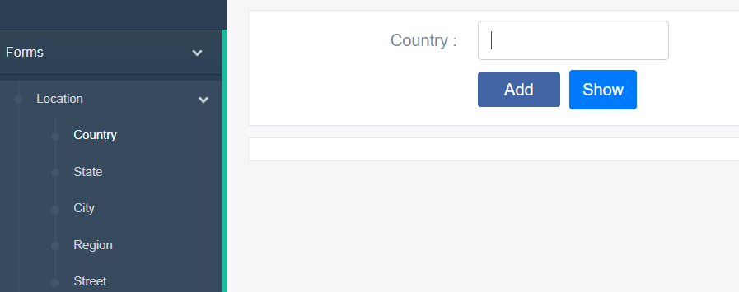

If admin does not enter country name the system will message “please fill out this field”

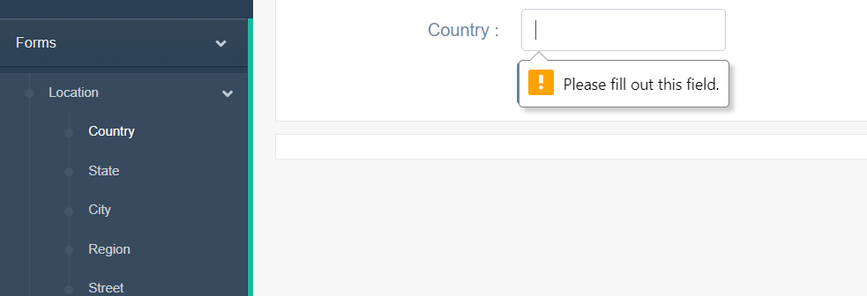

If admin enters country name with wrong format the system will message “Please match the requested format”

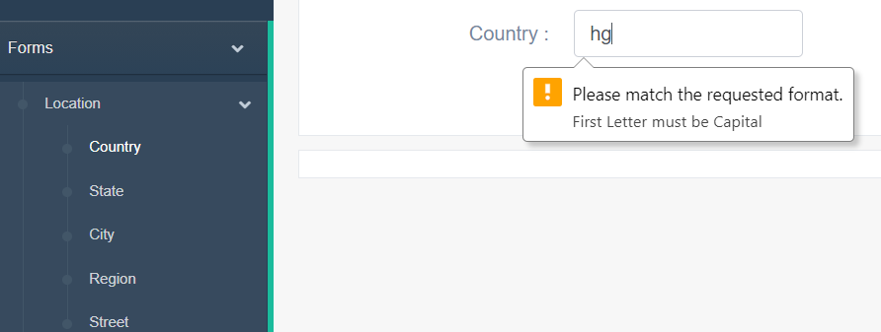

Else the admin enters the right format to country name the system will message “Country created successfully”

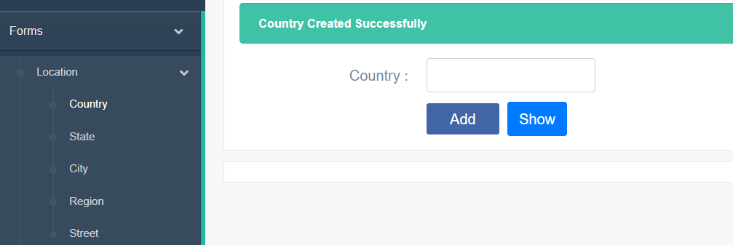

Admin can know all countries by using show button or choose country from table, location in slide bar

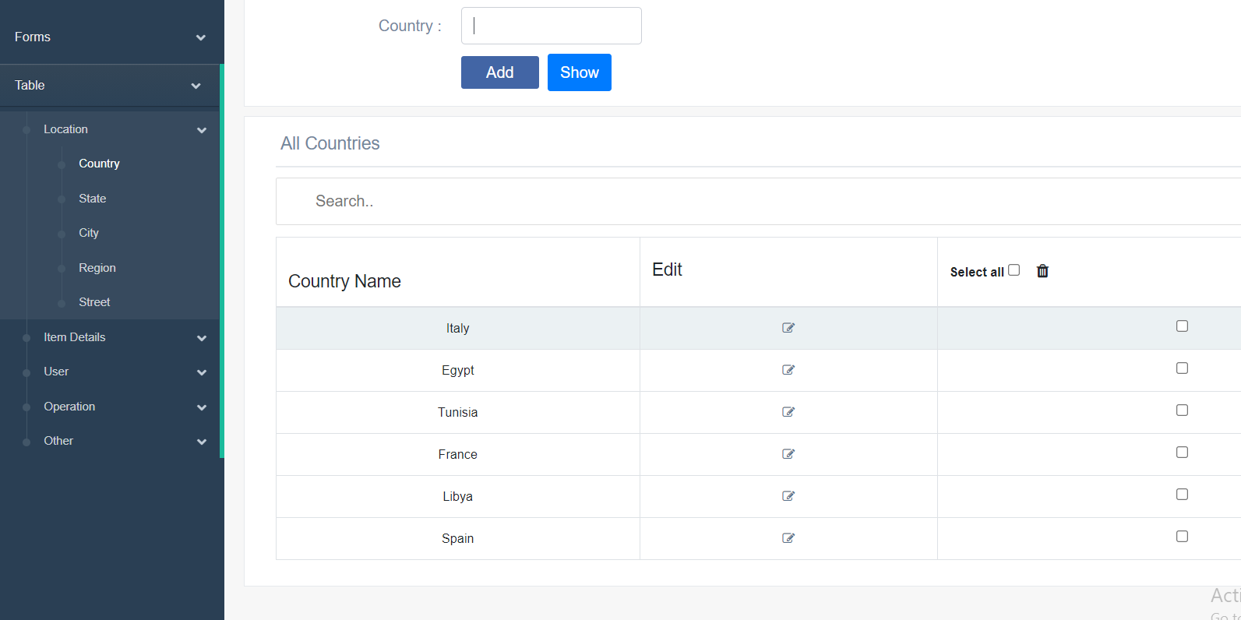

Admin can edit main type by clicking edit icon

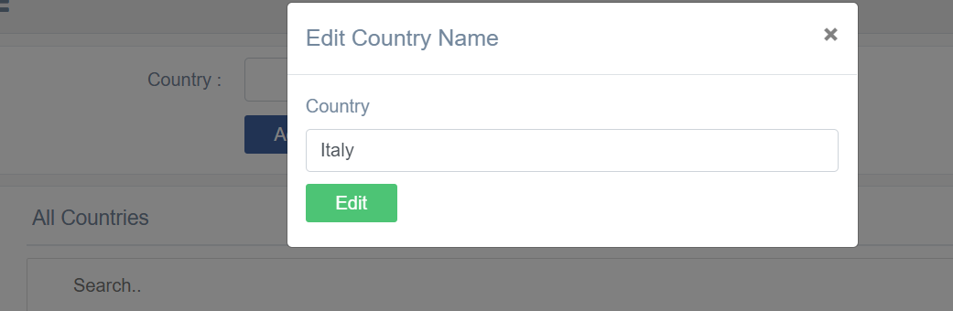

Admin can edit the country name and clicks edit the system will show message “Country edited successfully”

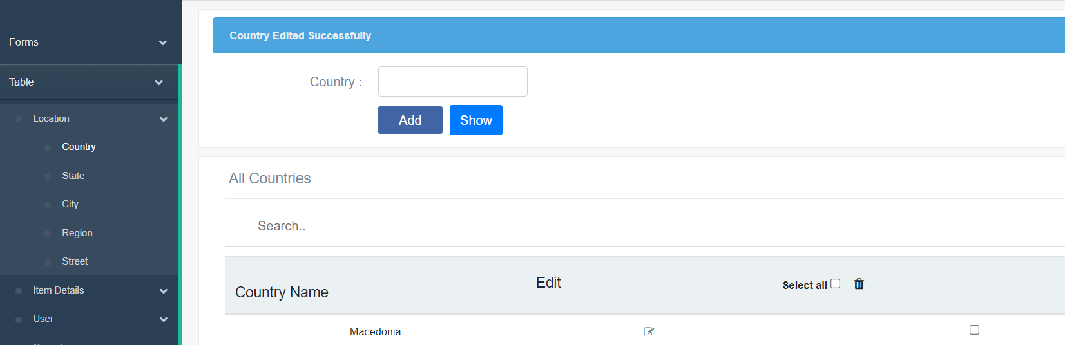

Admin can delete any country by using the checkbox then clicks trash icon

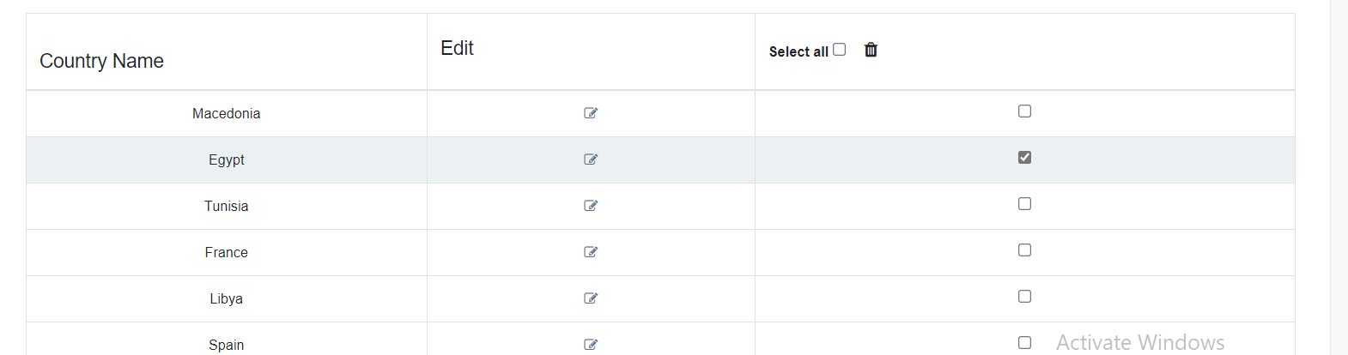

System will show message are you sure you want to delete

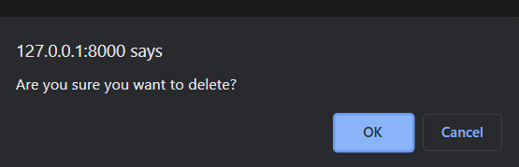

If the admin clicks ok the system will redirect same page without the deleting country and message “Country deleted successfully”.

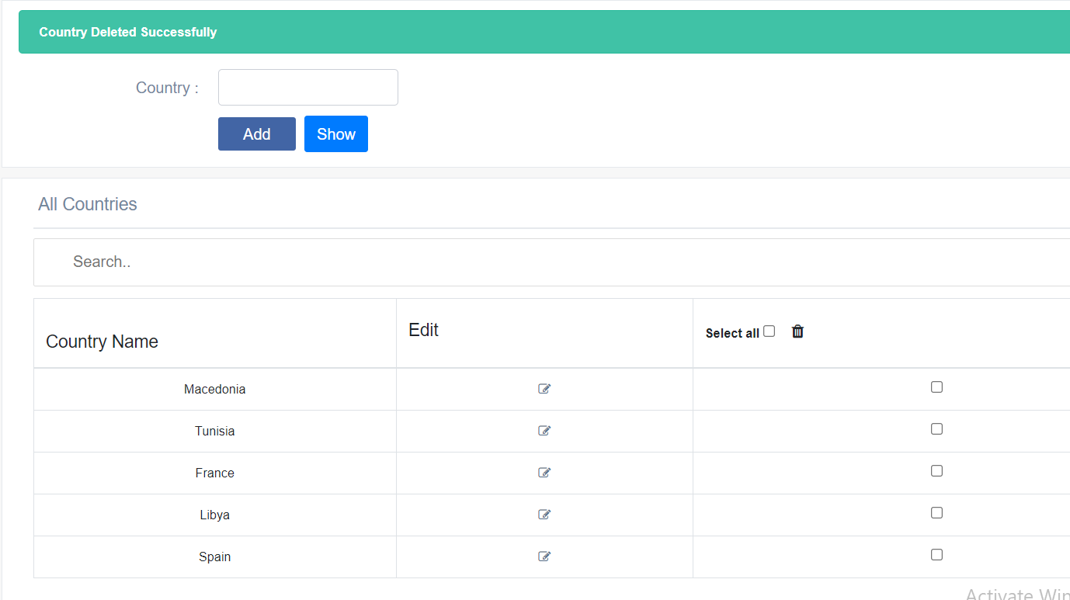

2)Add State

Before the admin write State name, must choose Country name

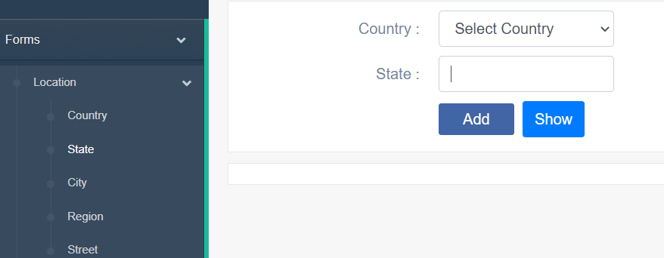

If the admin write state name without choosing country name the system will message “You must select all values”

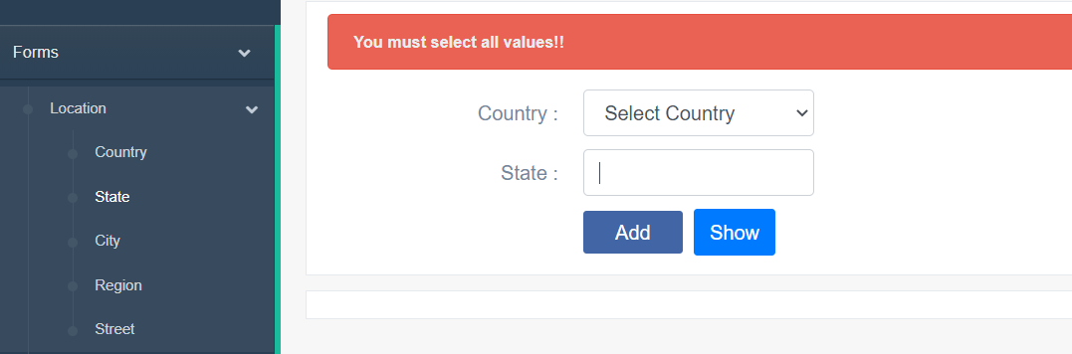

If admin does not enter state name the system will message “please fill out this field”

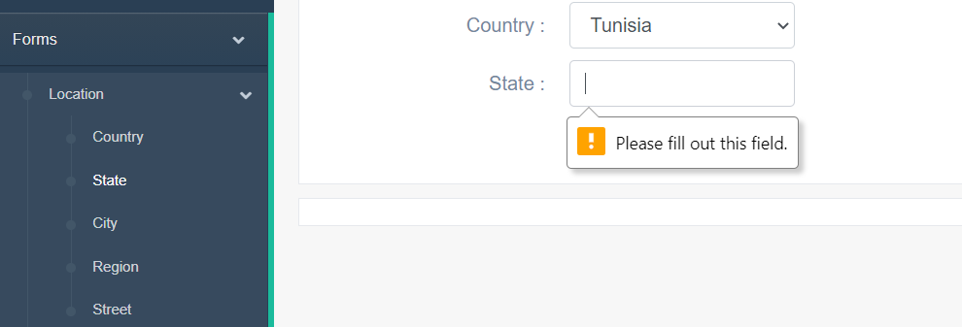

If admin enters state name with wrong format the system will message “Please match the requested format”

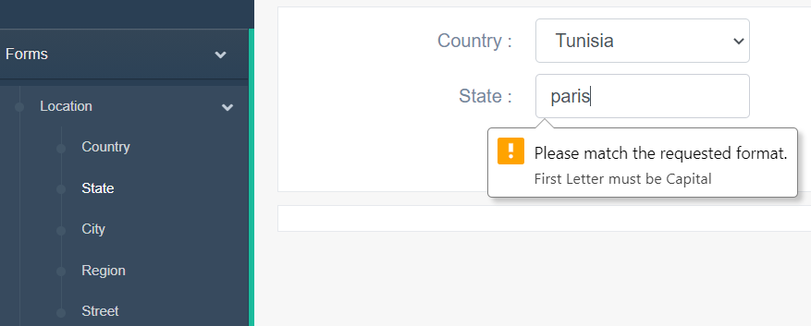

Else the admin enters the right format to state name the system will message “State created successfully”

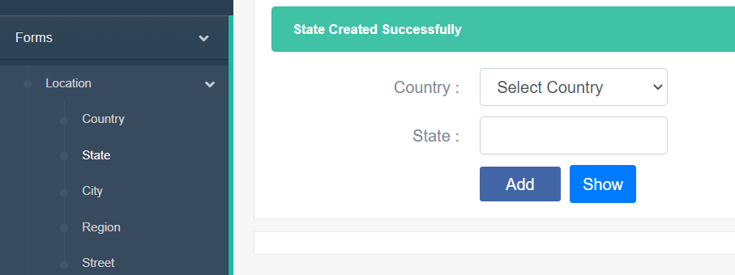

Admin can know all states by using show button or choose state from table, location in slide bar

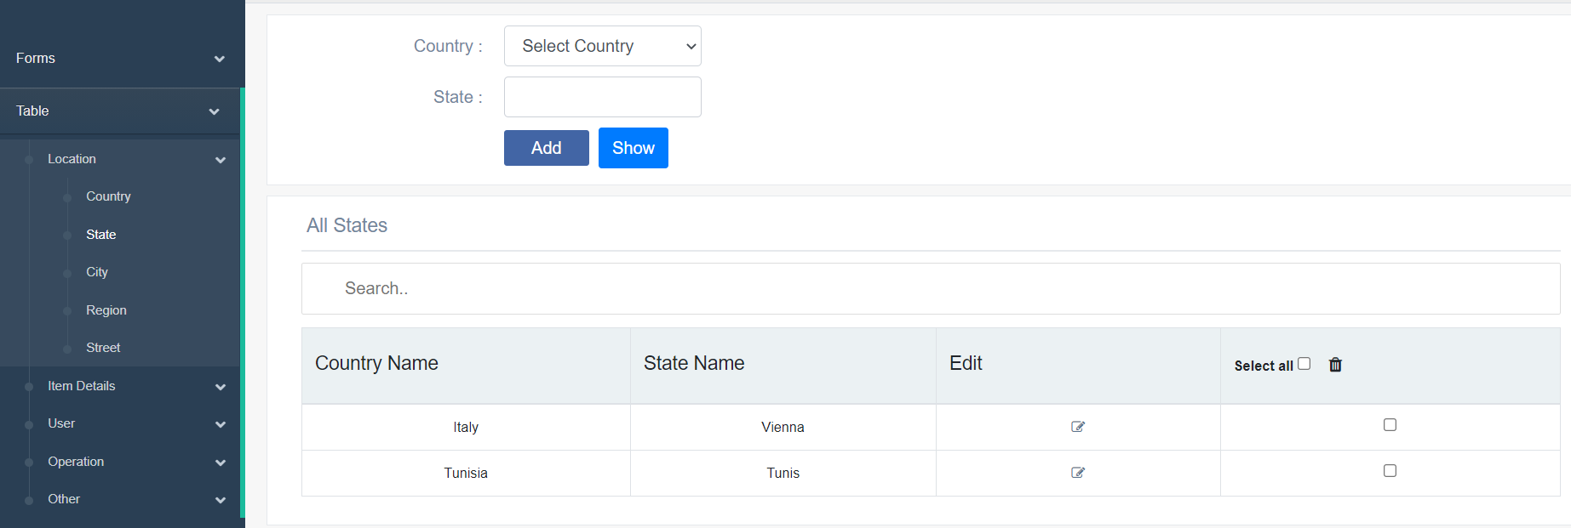

3)Add city name

Before the admin write City name, must choose Country name then state name

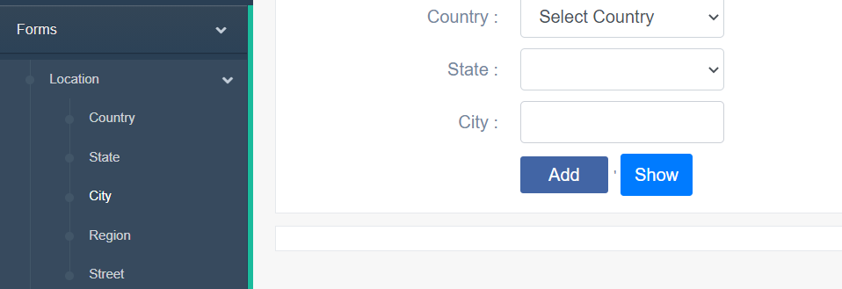

If the admin writes city name without choosing country name or state name the system will message “You must select all values”

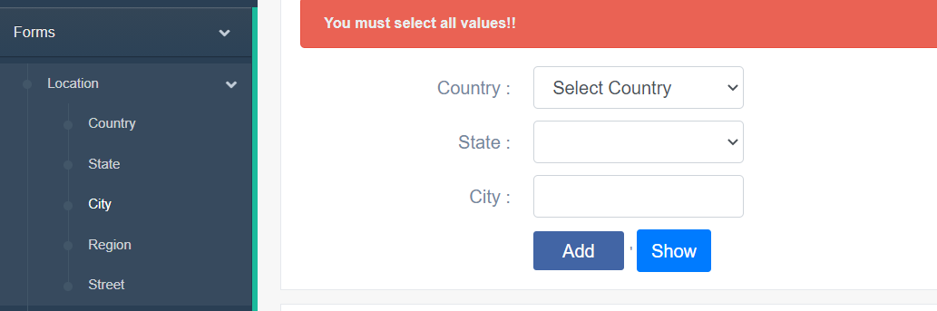

If admin does not enter city name the system will message “please fill out this field”

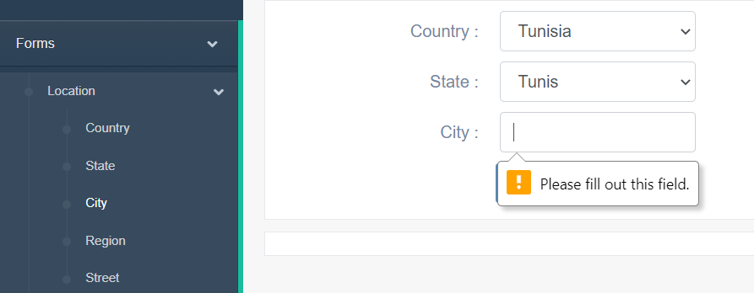

If admin enters city name with wrong format the system will message “Please match the requested format”

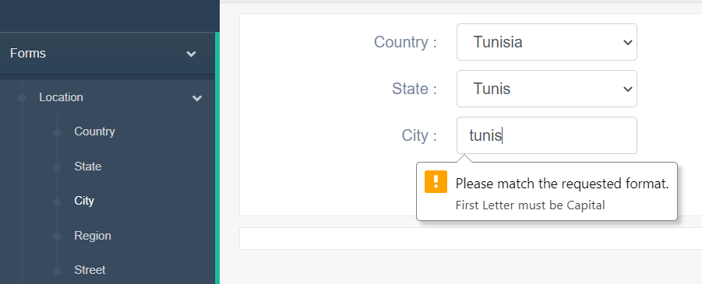

Else the admin enters the right format to city name the system will message

“city created successfully”

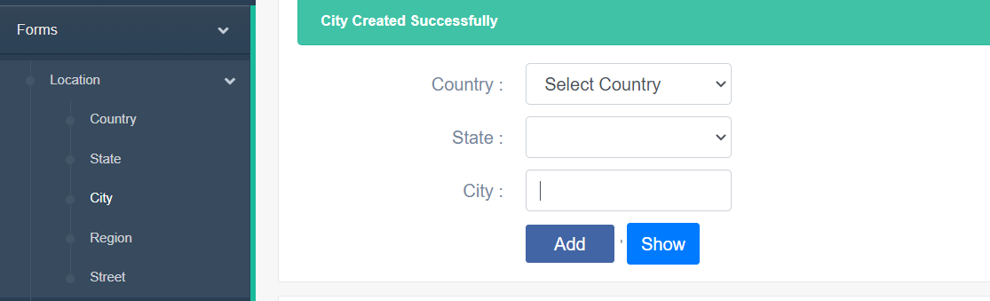

Admin can know all cities by using show button or choose city from table, location in slide bar

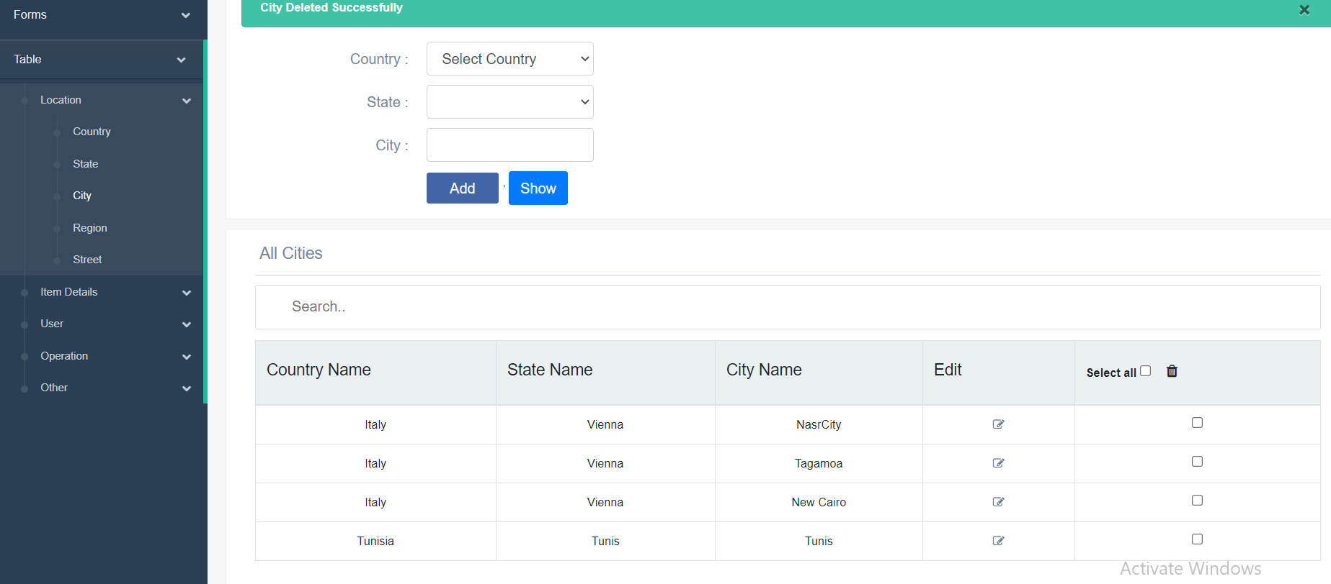

4)Add Region name

Before the admin write region name, must choose Country name then state name then city name

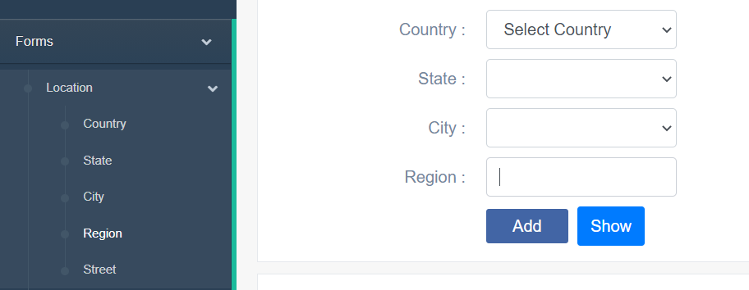

If the admin writes region name without choosing country name or state name or city name the system will message “You must select all values”

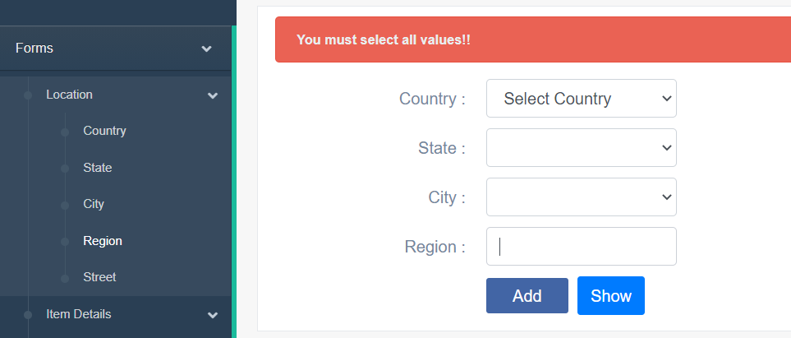

If admin does not enter region name the system will message “please fill out this field”

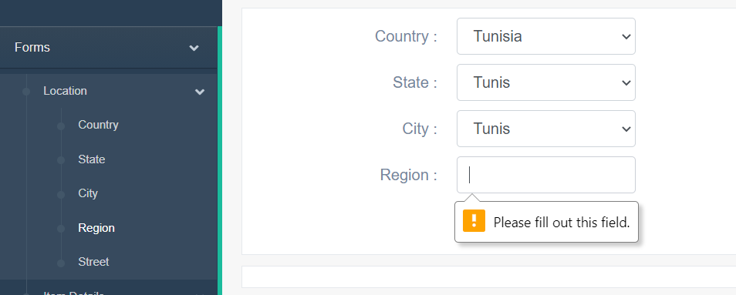

If admin enters region name with wrong format the system will message “Please match the requested format”

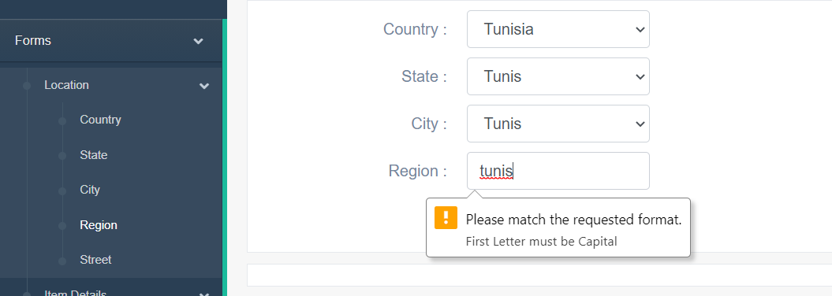

Else the admin enters the right format to region name the system will message

“Region created successfully”

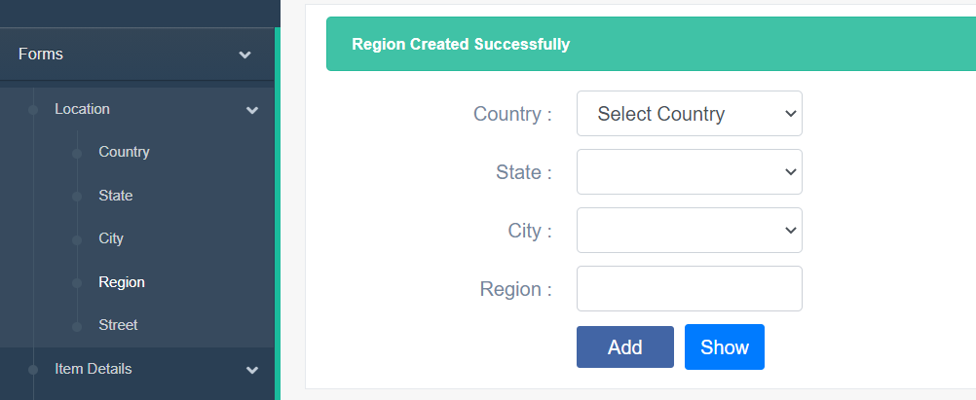

Admin can know all regions by using show button or choose region from table, location in slide bar

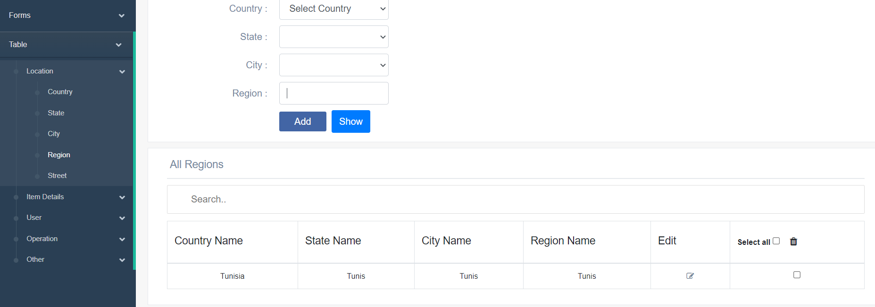

5)Add Street name

Before the admin write street name, must choose Country name then state name then city name then region name

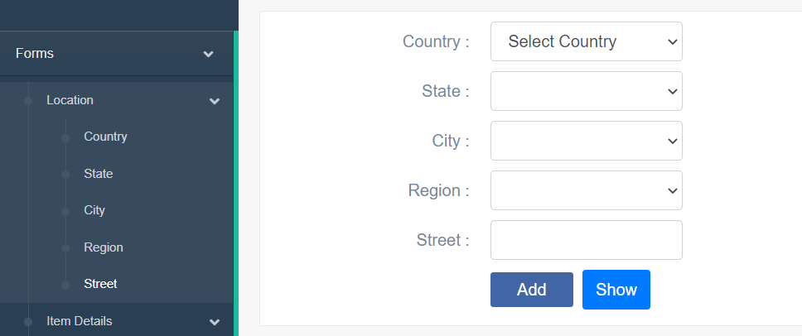

If the admin writes street name without choosing country name or state name or city name or region name the system will message “You must select all values”

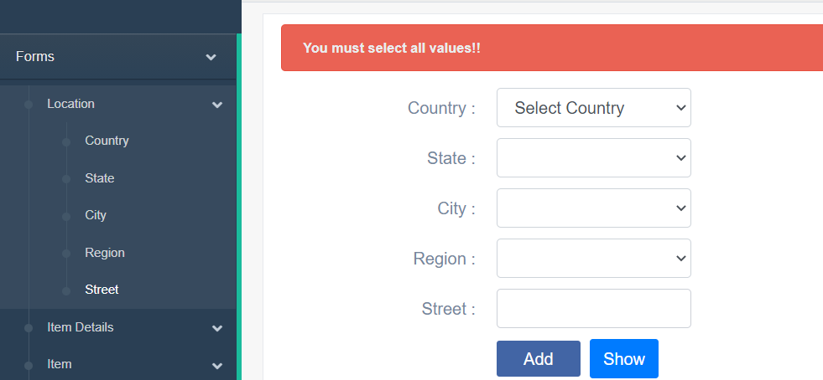

If admin does not enter street name the system will message “please fill out this field”

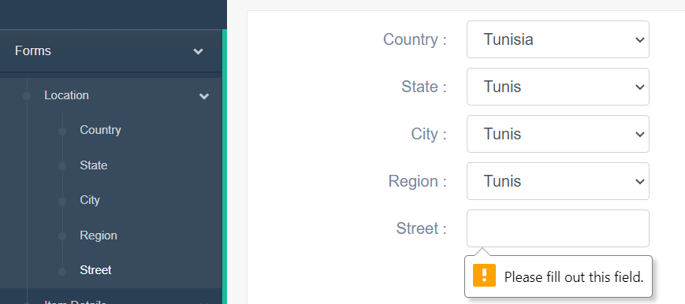

If admin enters street name with wrong format the system will message “Please match the requested format”

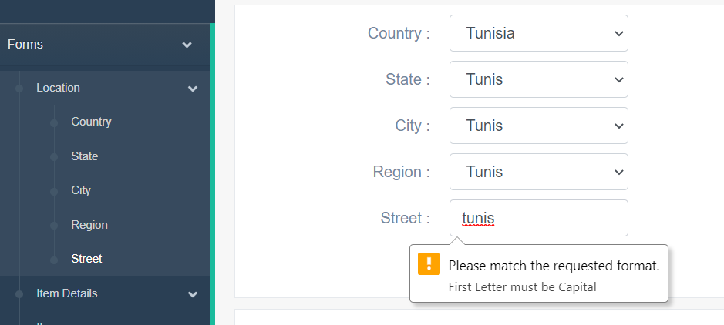

Else the admin enters the right format to street name the system will message

“Region created successfully”

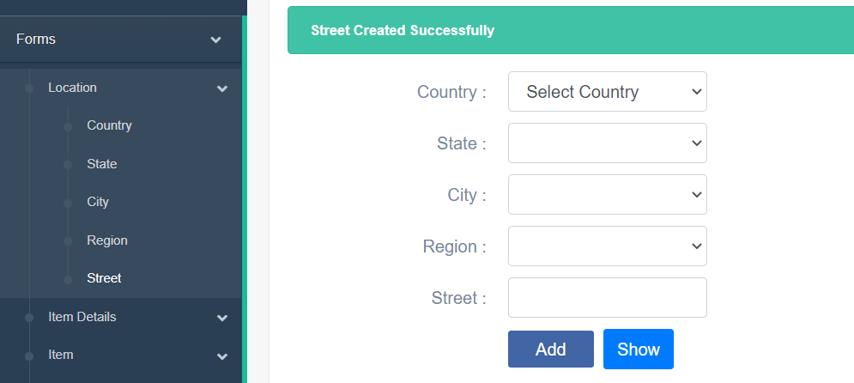

Admin can know all streets by using show button or choose street from table, location in slide bar

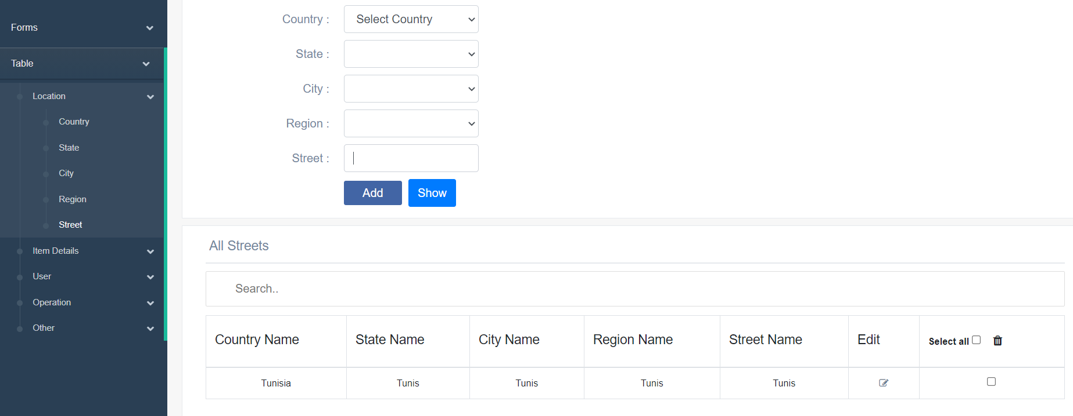

6)Add Main type

To add main type admin has to enter Main type

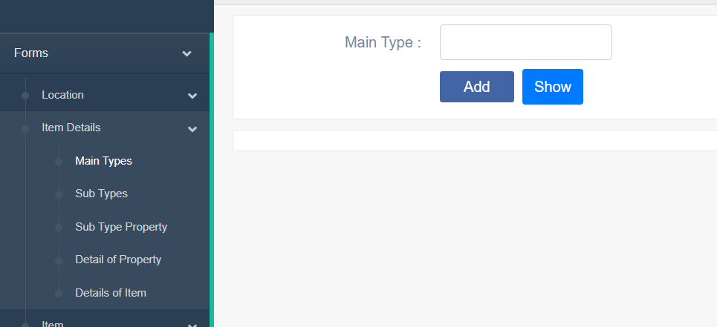

If admin does not enter main type the system will show message “please fill out this field”

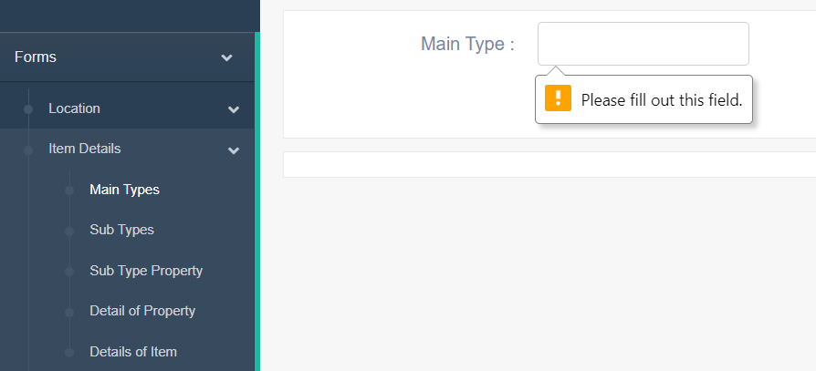

If admin enters main type with wrong format system will message “please match requested format”

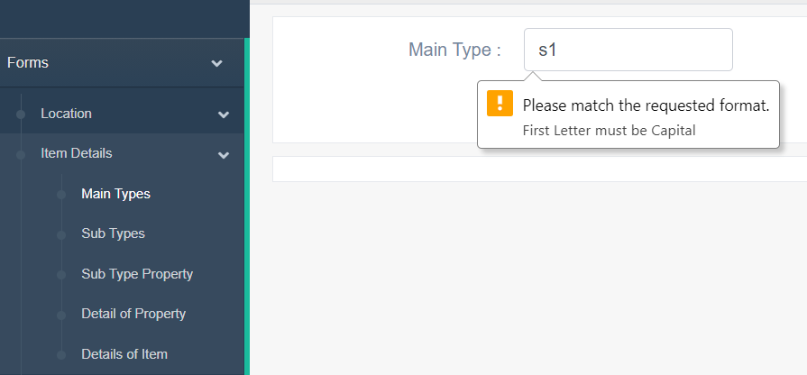

Else the system will message “Main type created successfully”

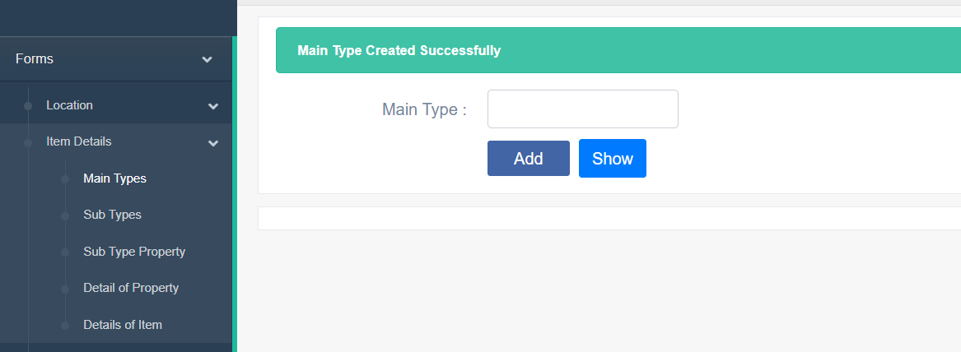

Admin can know all main types by using show button or choose Main type from table, item details in slide bar

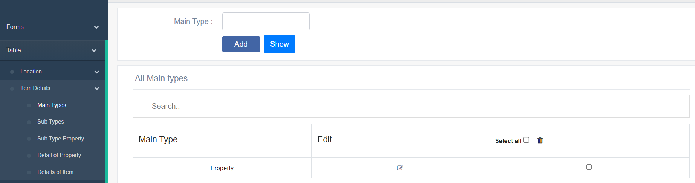

Admin can edit main type by clicking edit icon

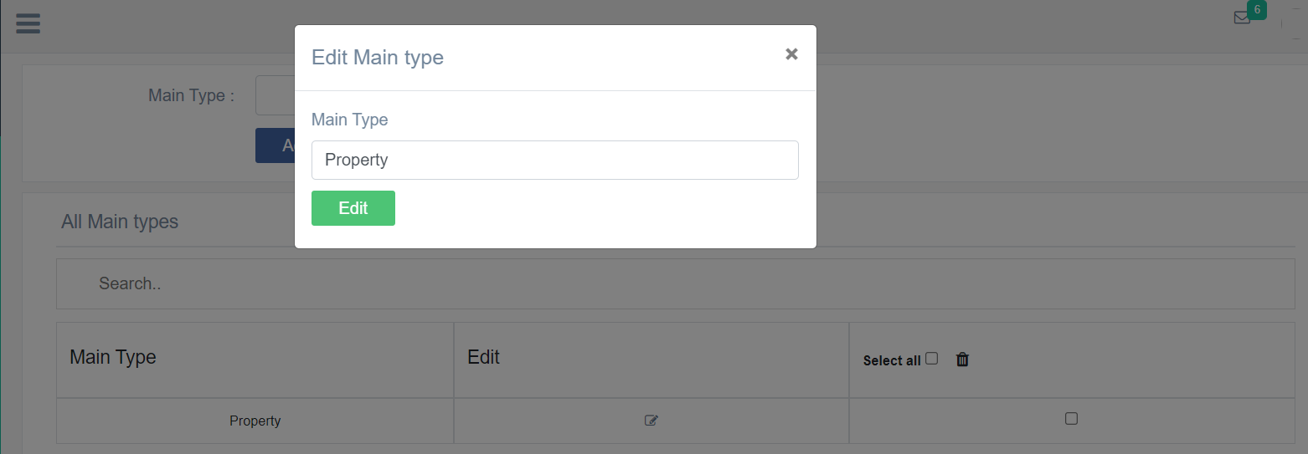

Admin can edit Main type and click edit to edit main type and system will show item edited successfully

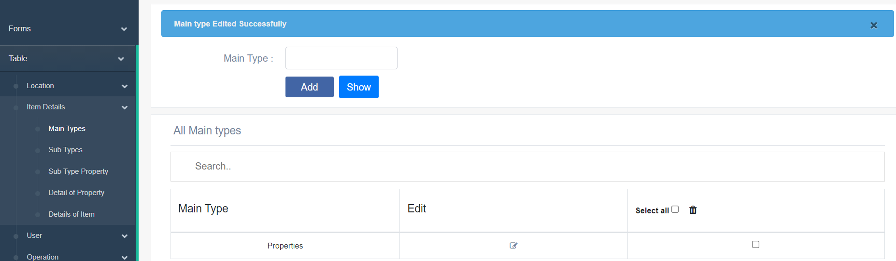

Admin can delete Main type by choosing main type check box then clicking trash can icon

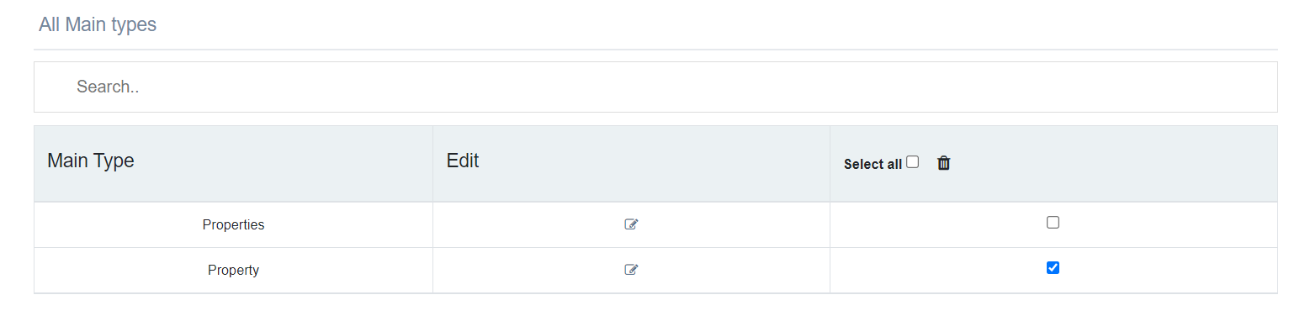

System will show message are you sure you want to delete



System will show main type deleted successfully

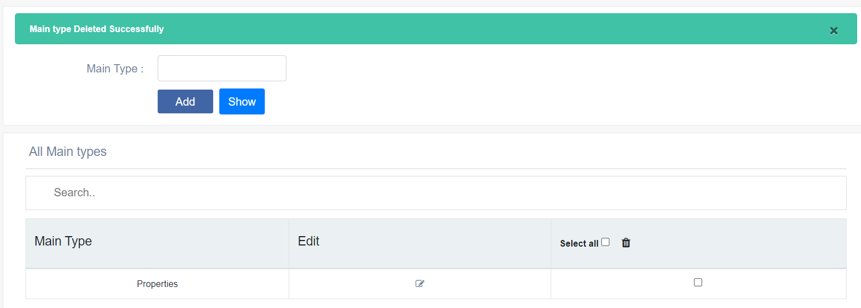

7-Add sub type

To add sub type admin has to choose Main type then add subtype

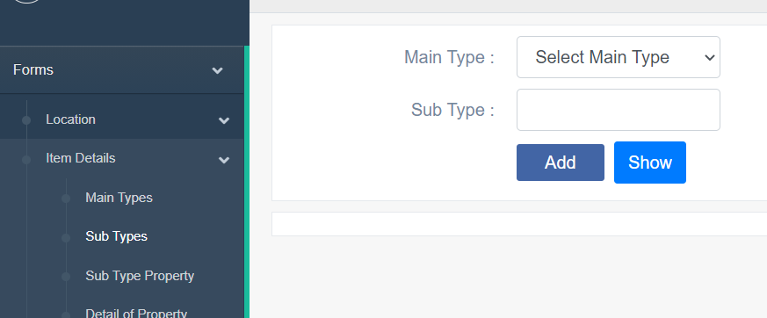

If admin does not enter sub type the system will show message “please fill out this field”

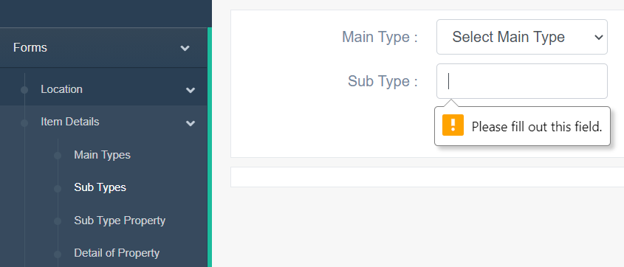

If admin enters sub type with wrong format system will message “please match requested format”

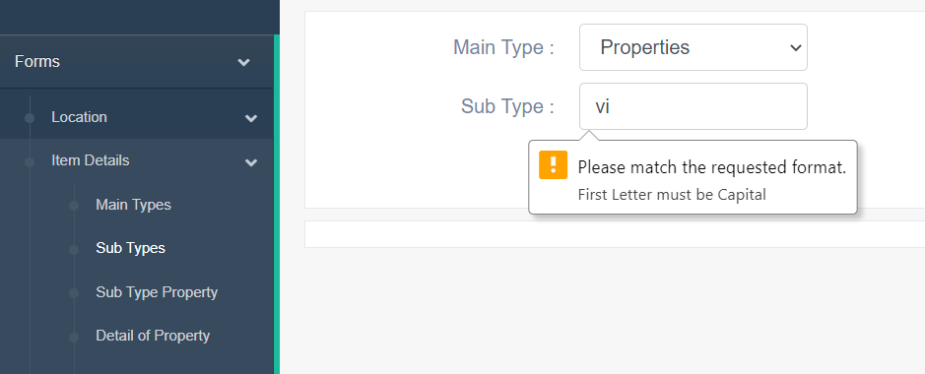

Else the system will message “Type created successfully”

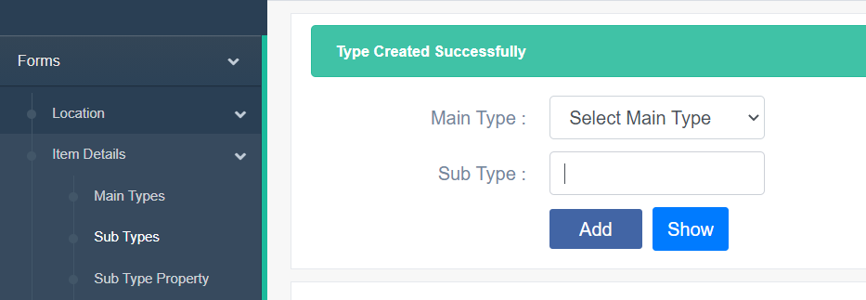

Admin can know all sub types by using show button or choose sub type from table, Item Details in slide bar

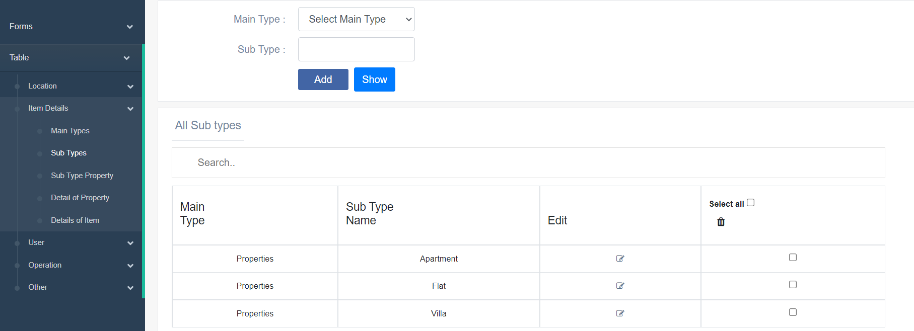

Admin can edit sub type by clicking edit icon

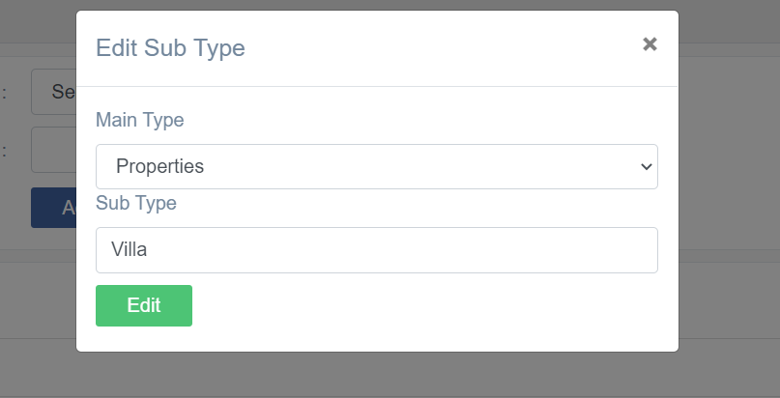

Admin can edit sub type and click edit to edit sub type and system will show item edited successfully

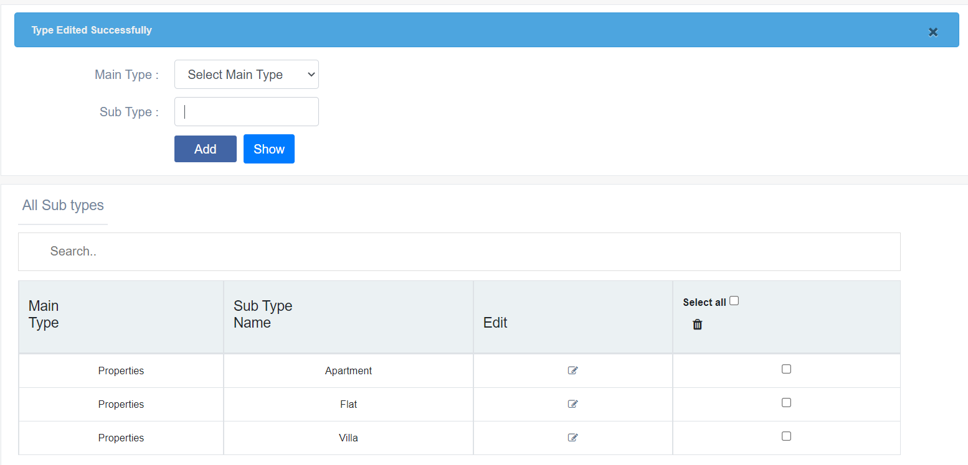

Admin can delete sub type by choosing sub type check box then clicking trash can icon

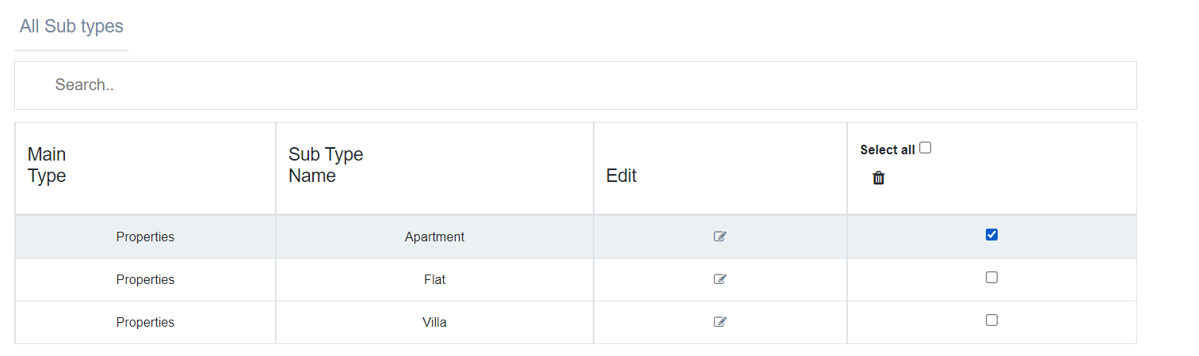

System will show message are you sure you want to delete



System will show Type deleted successfully

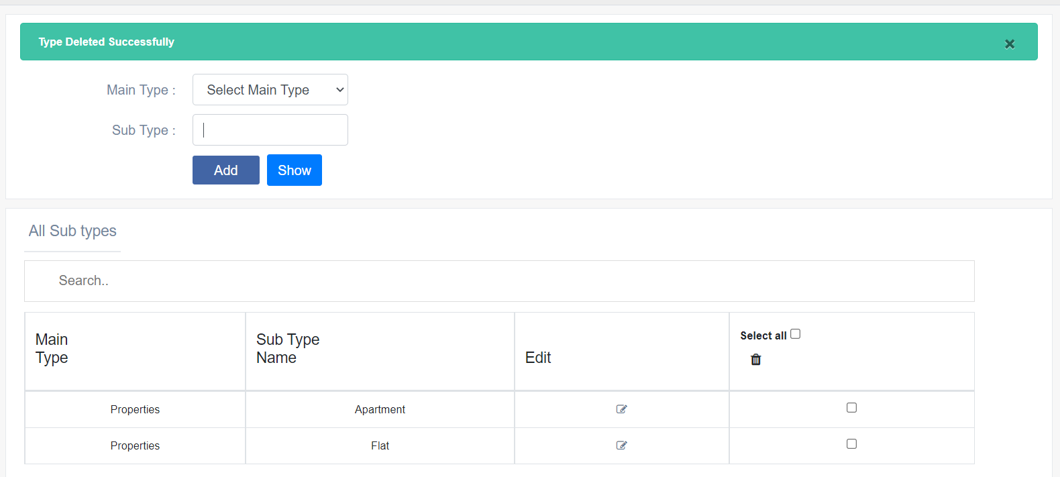

8)Add sub type property

To add sub type property admin has to choose Main type and subtype then enter sub type property and click add

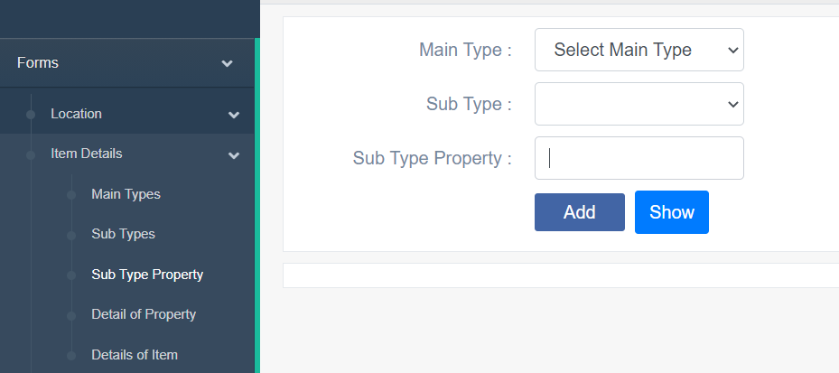

If admin does not enter sub type property, the system will show message “please fill out this field”

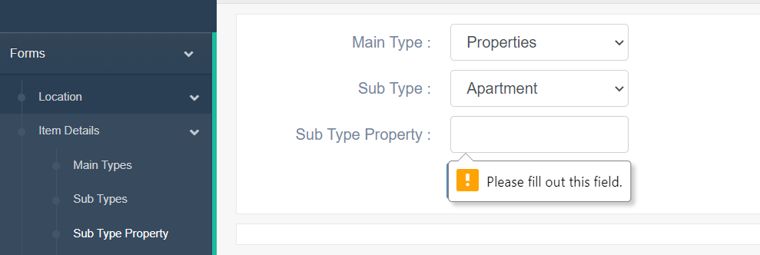

If admin enters sub type property with wrong format system will message “please match requested format”

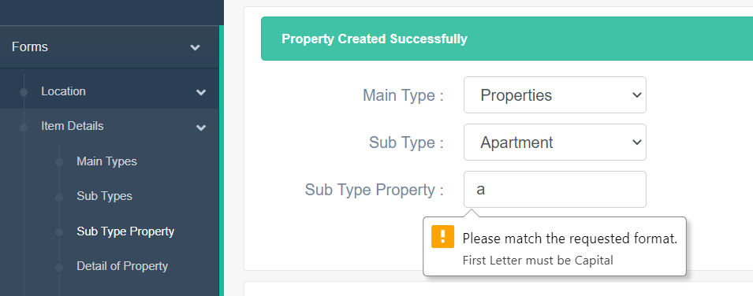

Else the system will message “Property created successfully”

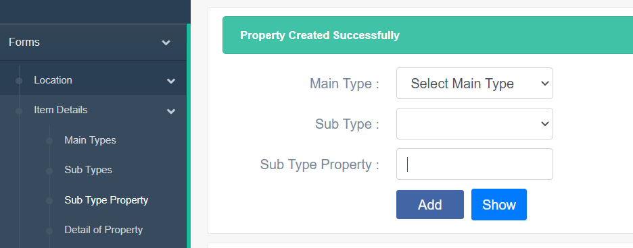

Admin can know all sub type properties by using show button or choose sub type property from table, Item Details in slide bar

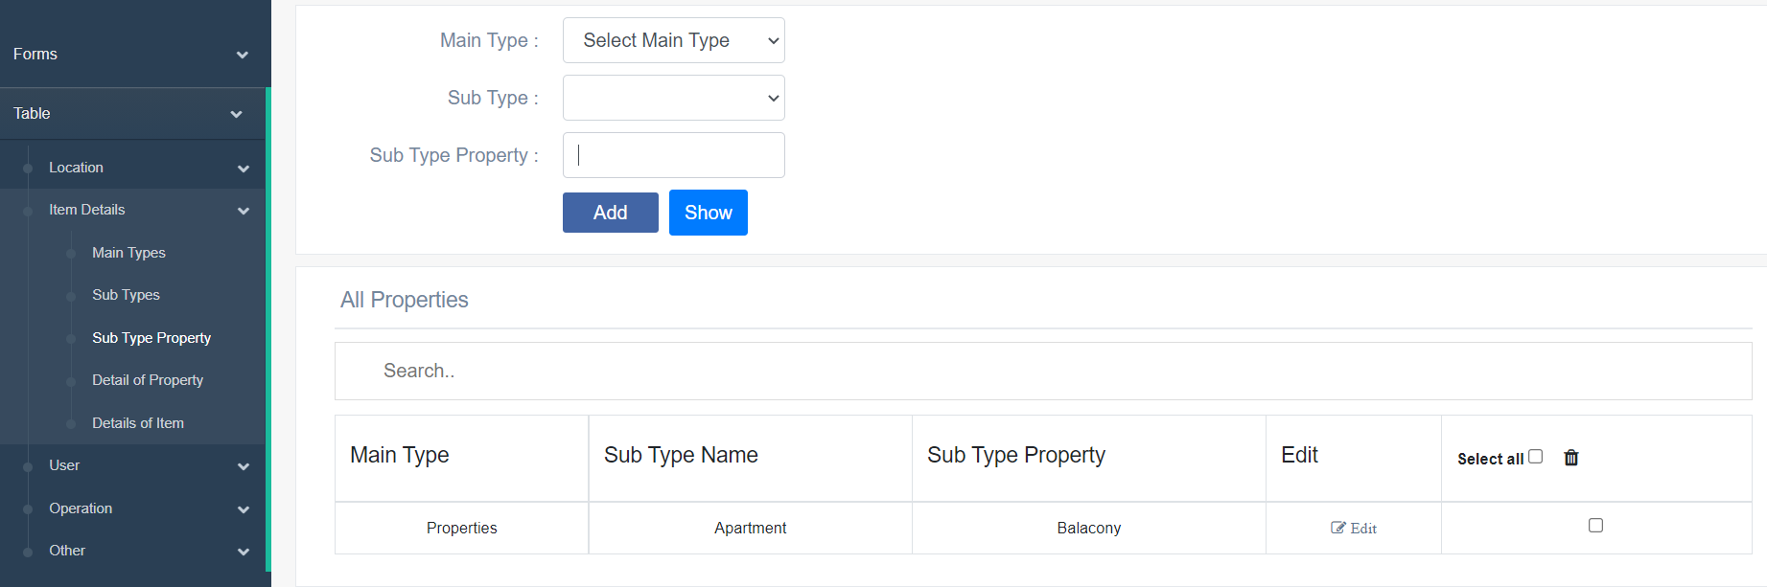

Admin can edit sub type property by clicking edit icon

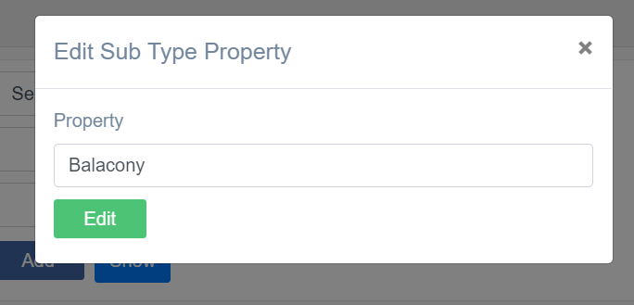

Admin can edit sub type property and click edit to edit sub type property and system will show item edited successfully

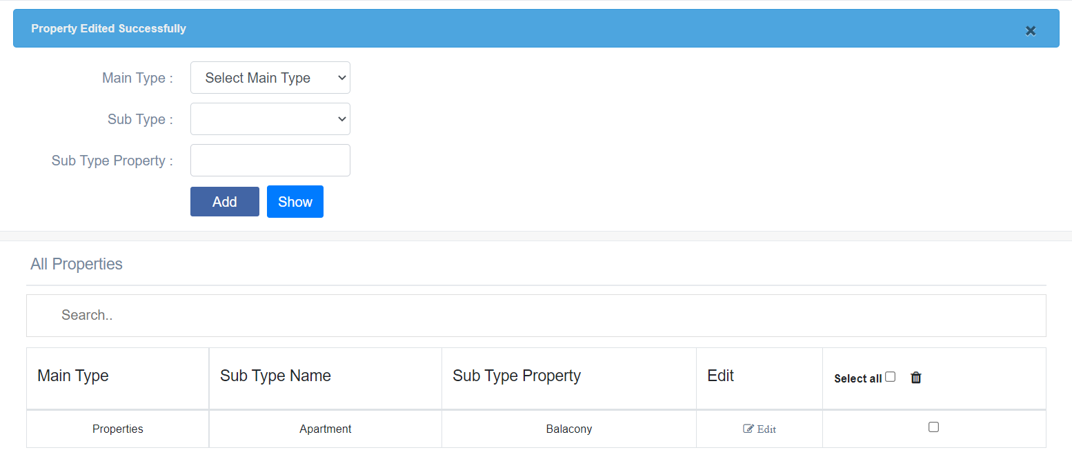

Admin can delete sub type property by choosing sub type property check box then clicking trash can icon

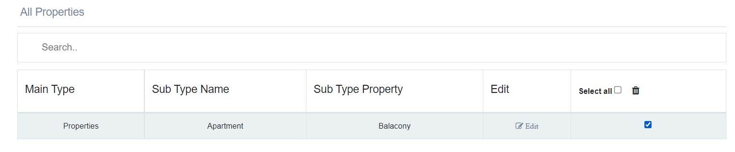

System will show message are you sure you want to delete



System will show Property deleted successfully

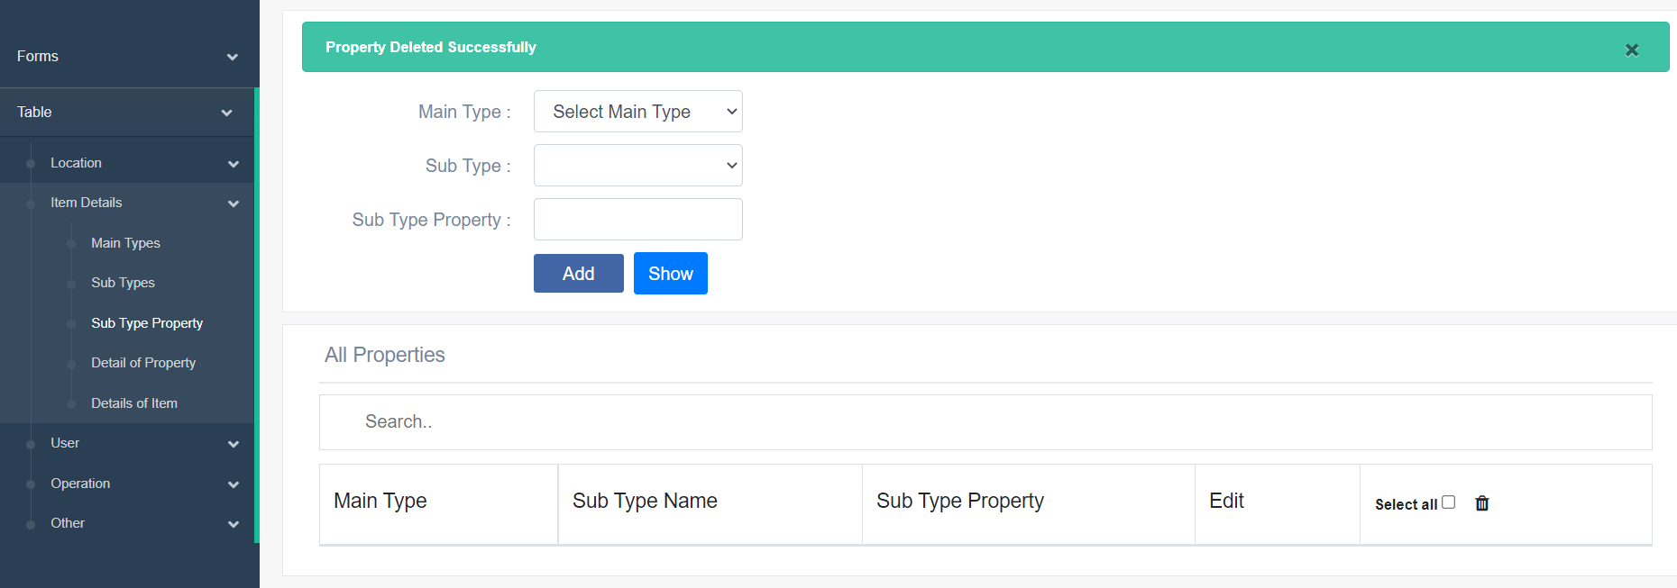

9)Add property detail

To add property detail admin has to choose Main type , sub type , data type and sub type property then enter detail and click add

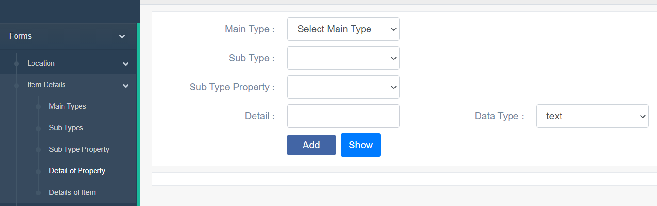

Else the system will message “Property Detail created successfully”

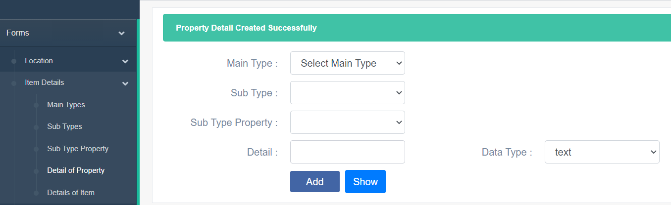

Admin can know all property details by using show button or choose details of property from table, Item Details in slide bar



Admin can edit sub type property by clicking edit icon

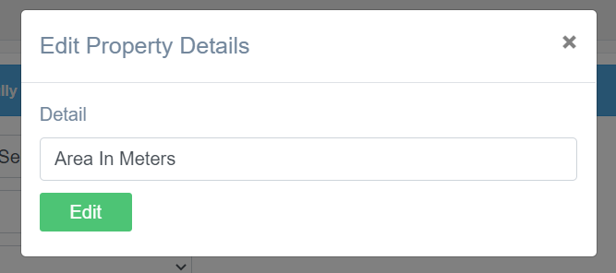

Admin can edit Property detail and click edit to edit property detail and system will show Property Detail edited successfully

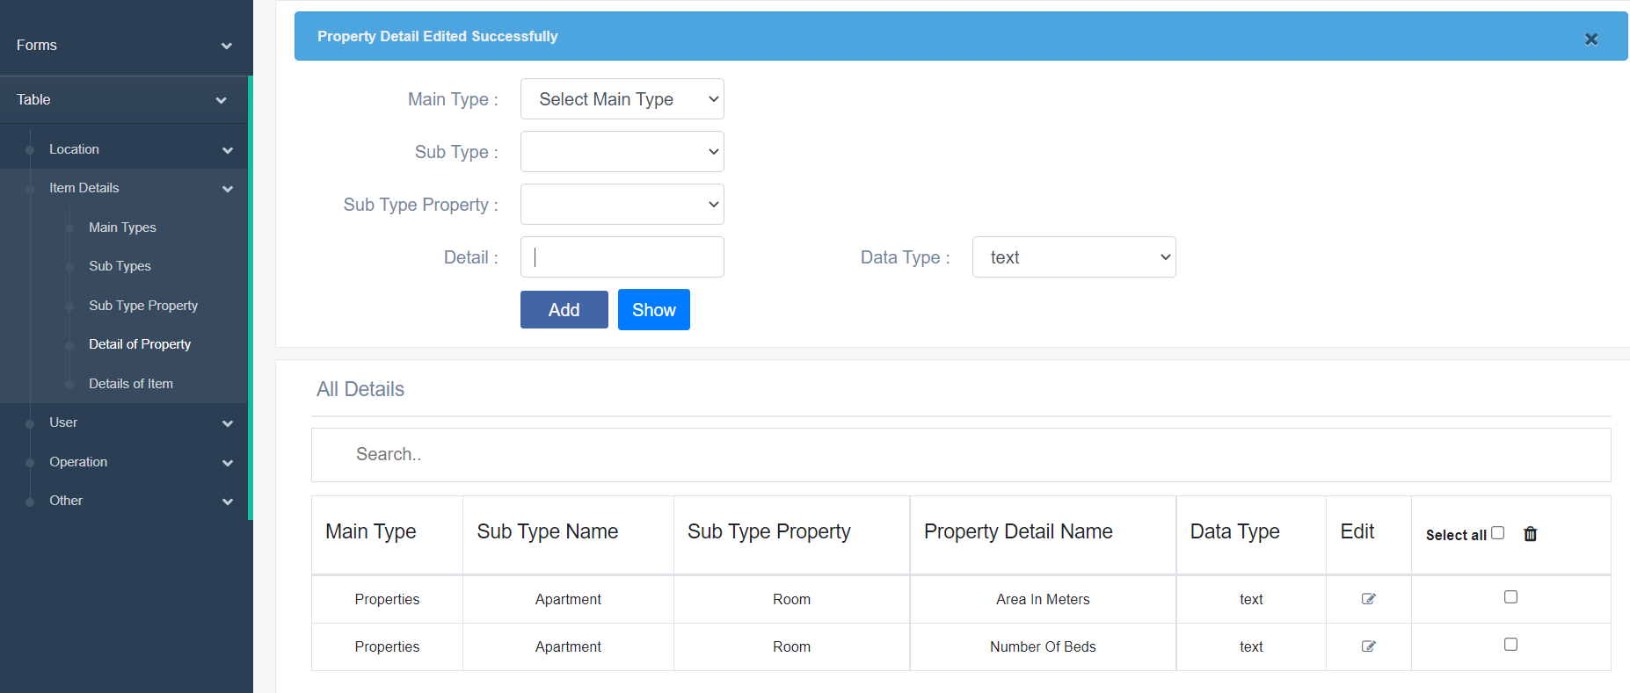

Admin can delete property detail by choosing property detail check box then clicking trash can icon

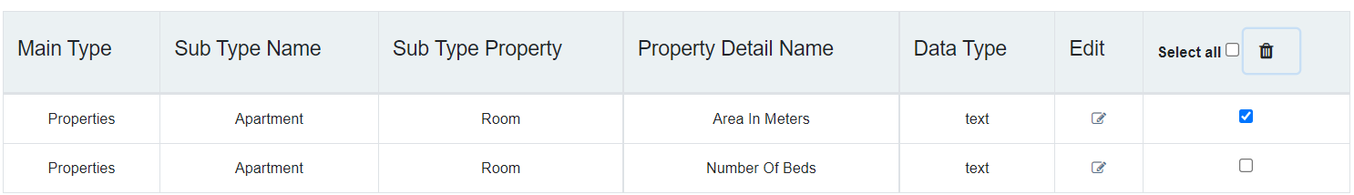

System will show message are you sure you want to delete



System will show Property Detail deleted successfully

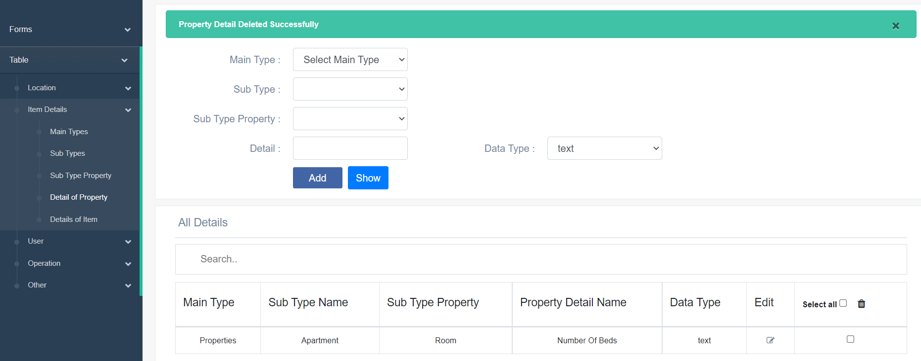

10)Add user type

To add user type admin has to enter Main type

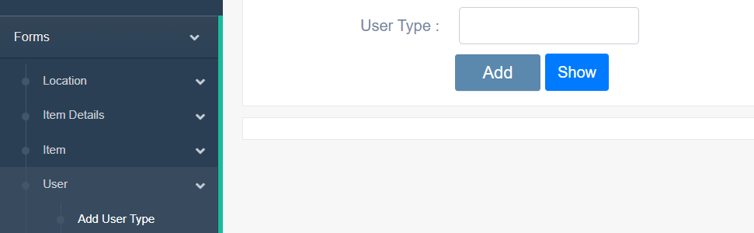

If admin does not enter user type the system will show message “please fill out this field”

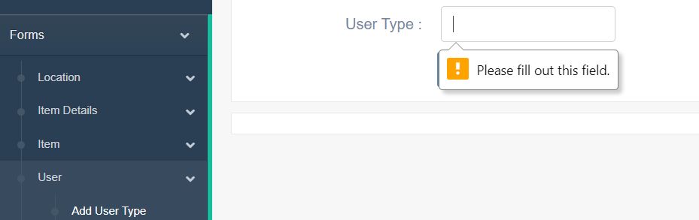

If admin enters user type with wrong format system will message “please match requested format”

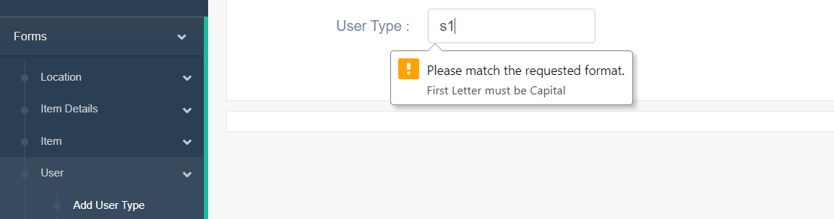

Else the system will message “Type created successfully”

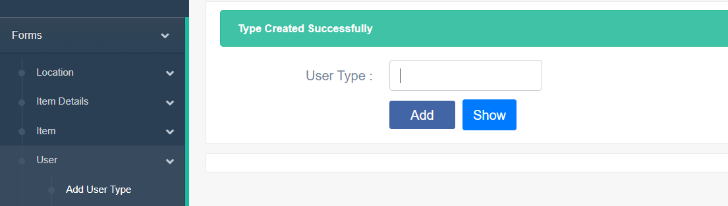

Admin can know all user type by using show button or choose User Type from table, User in slide bar

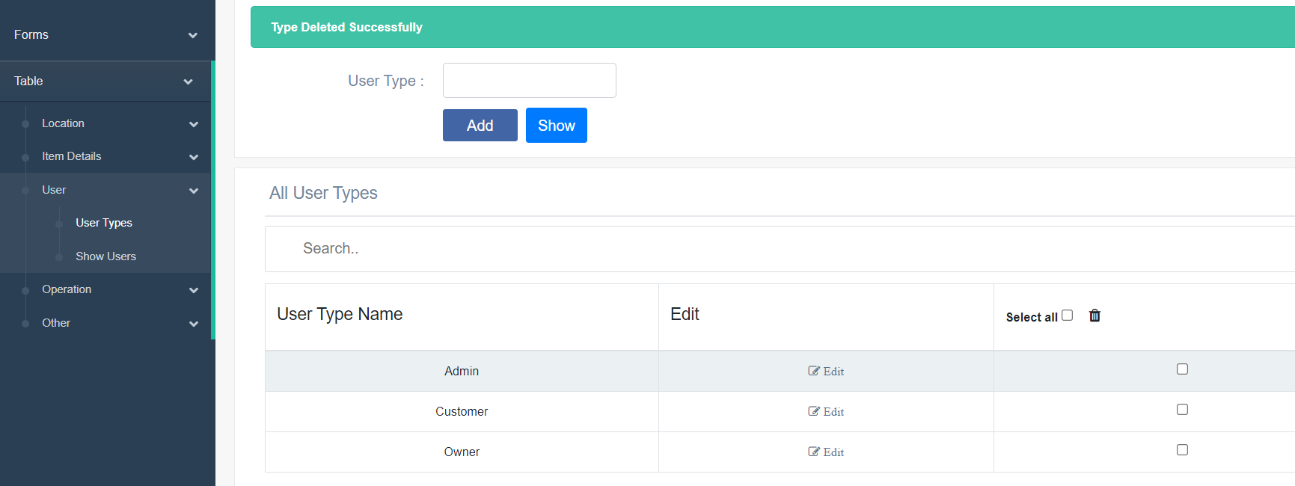

Admin can edit user type by clicking edit icon

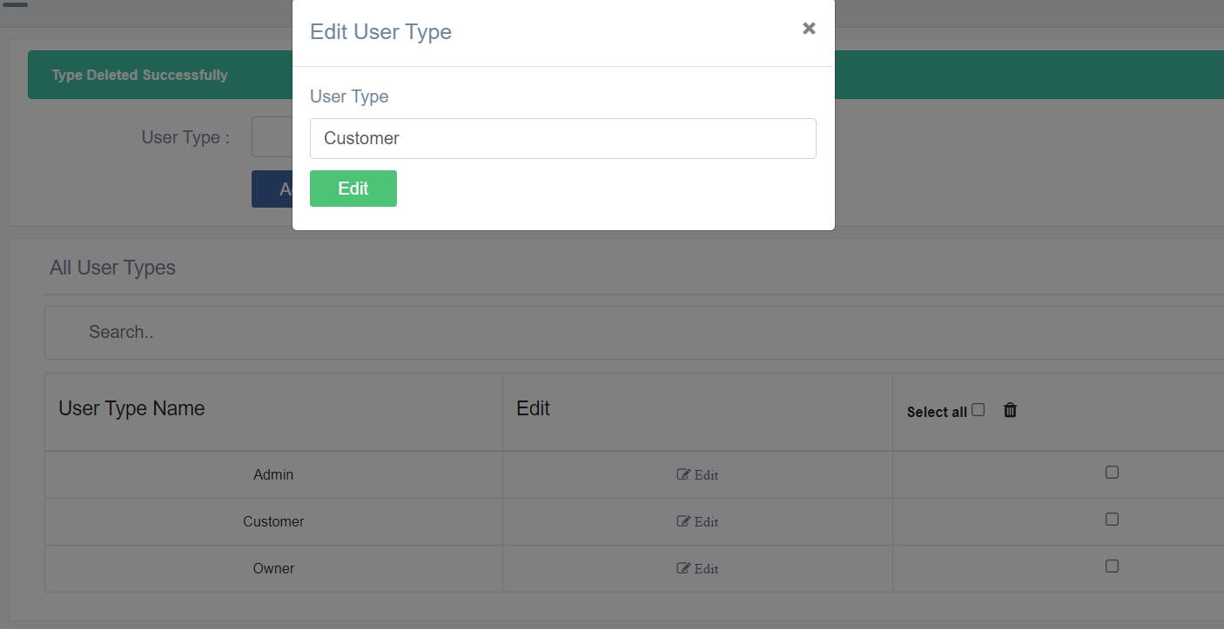

Admin can edit Main type and click edit to edit main type and system will show Customer edited successfully

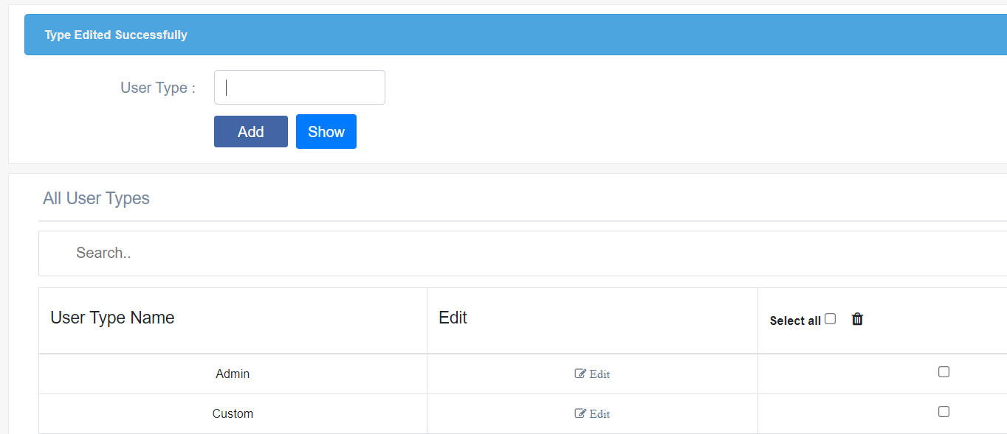

Admin can delete user type by choosing main type check box then clicking trash can icon

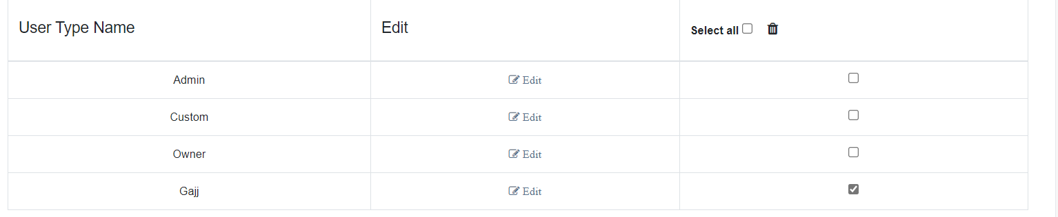

System will show message are you sure you want to delete



System will show Type deleted successfully

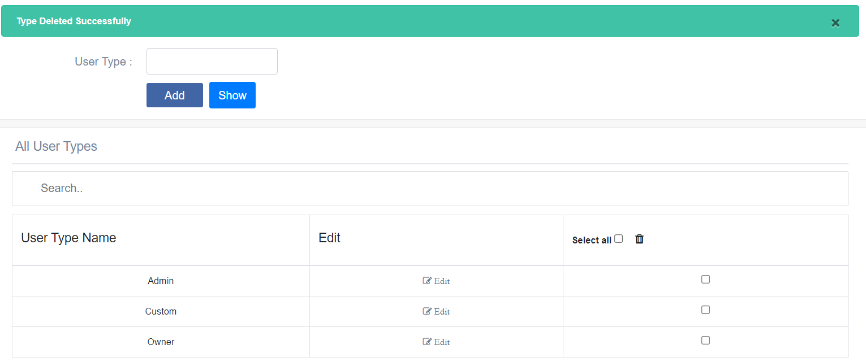

11)Add Item

The admin search for item’s owner by email

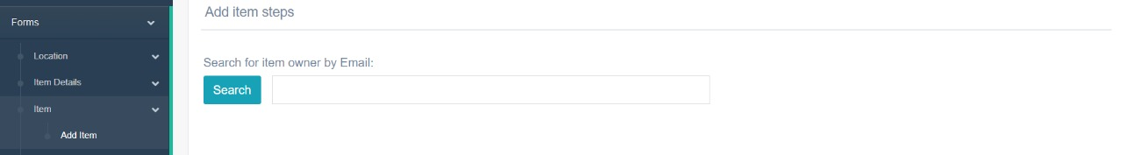

The admin selects email of the owner and press next

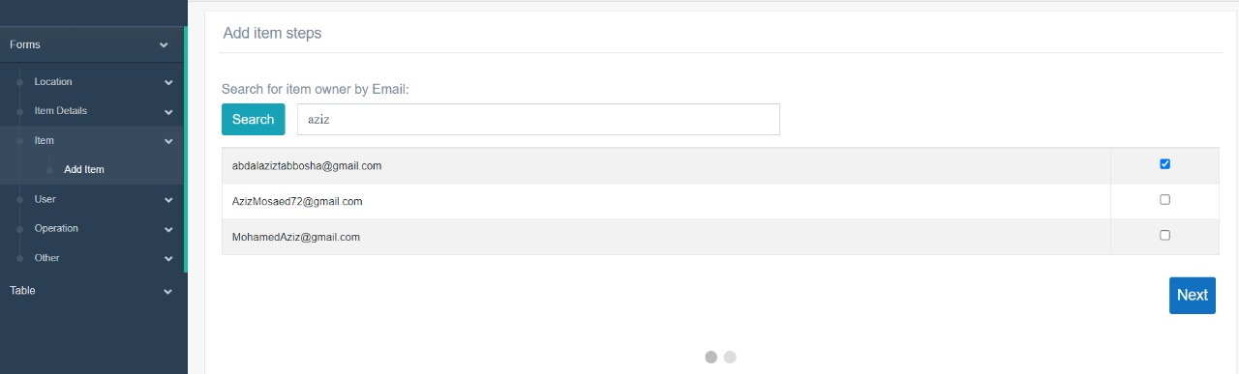

After The admin clicks next, the admin has to enter item name and location

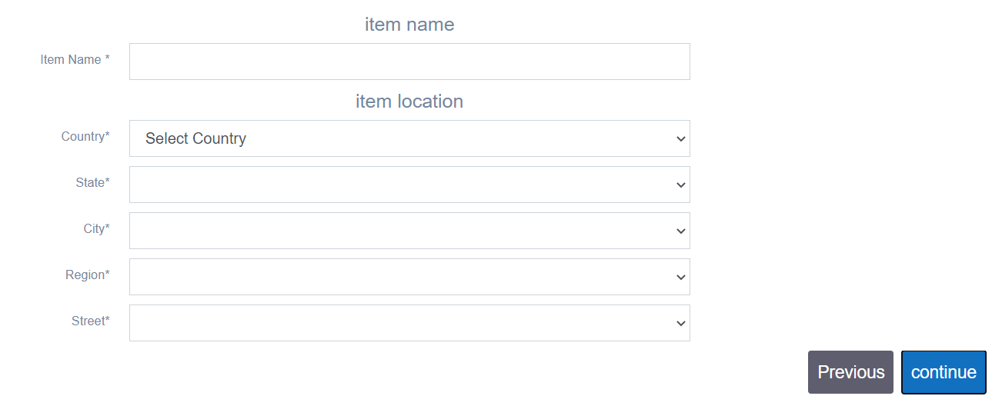

After the admin clicks continue, the admin has to choose what is the main type and sub type

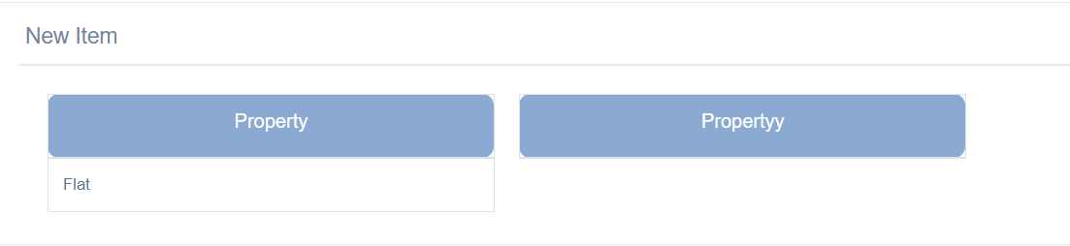

After the admin chooses subtype, the admin chooses subtype property

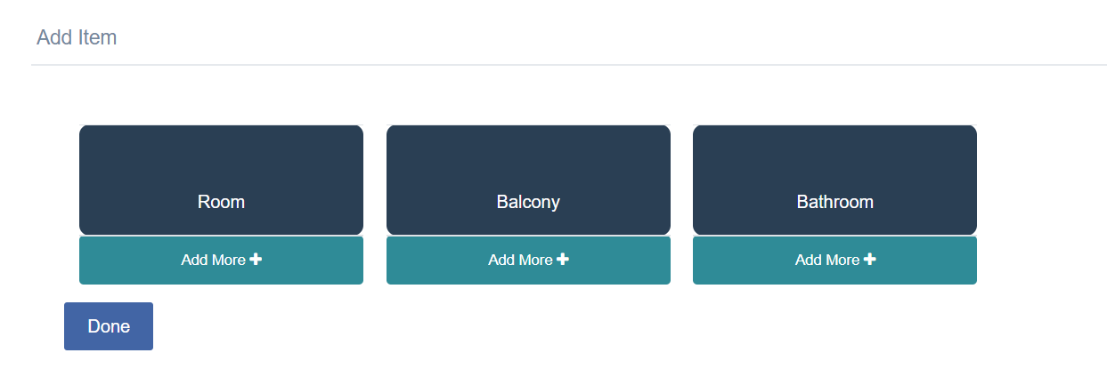

After the admin chooses subtype, the admin has to enter the property detail

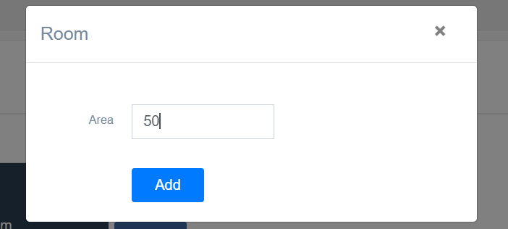

After the admin clicks Add then clicks done the item details appears

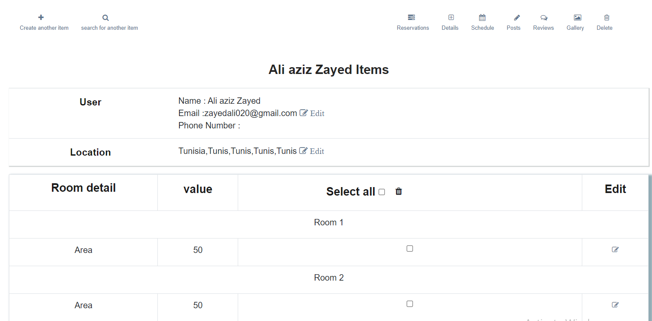

12)Add user

The admin has to enter first page of step form

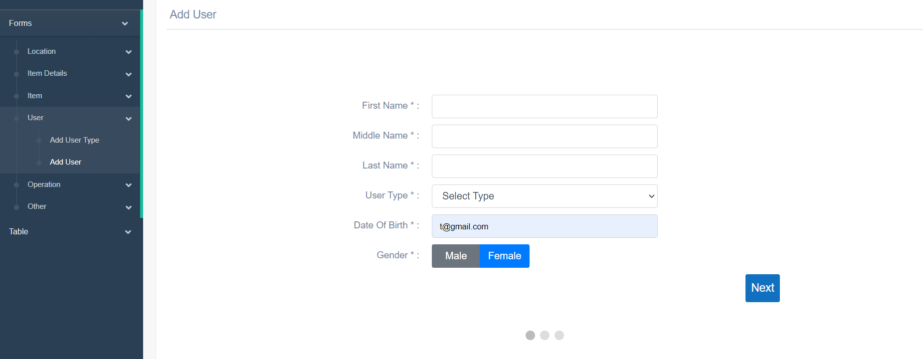

If admin leave any field, the system will give the text area red color

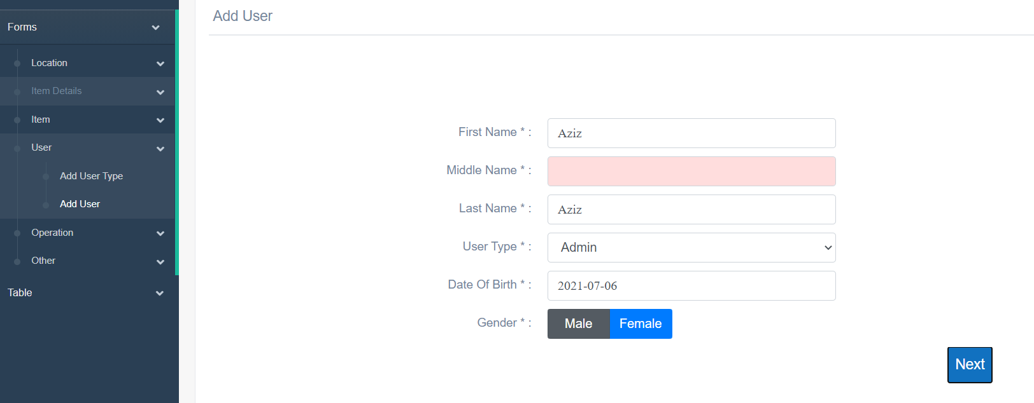

If the admin enters all the field with right format the system will get the step page of wizard form

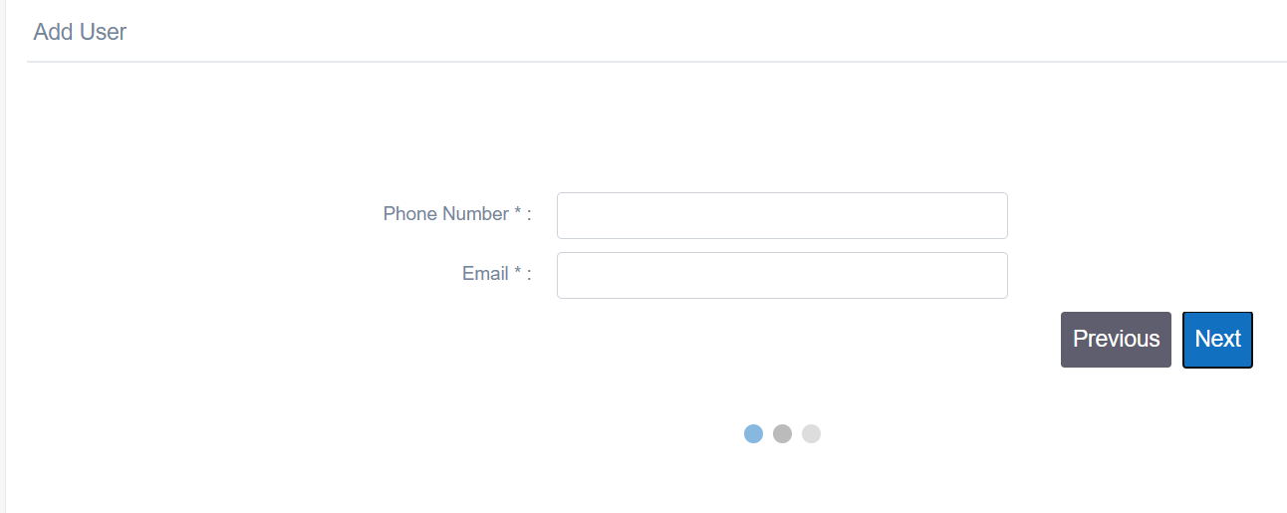

If admin leave any field, the system will give the text area red color

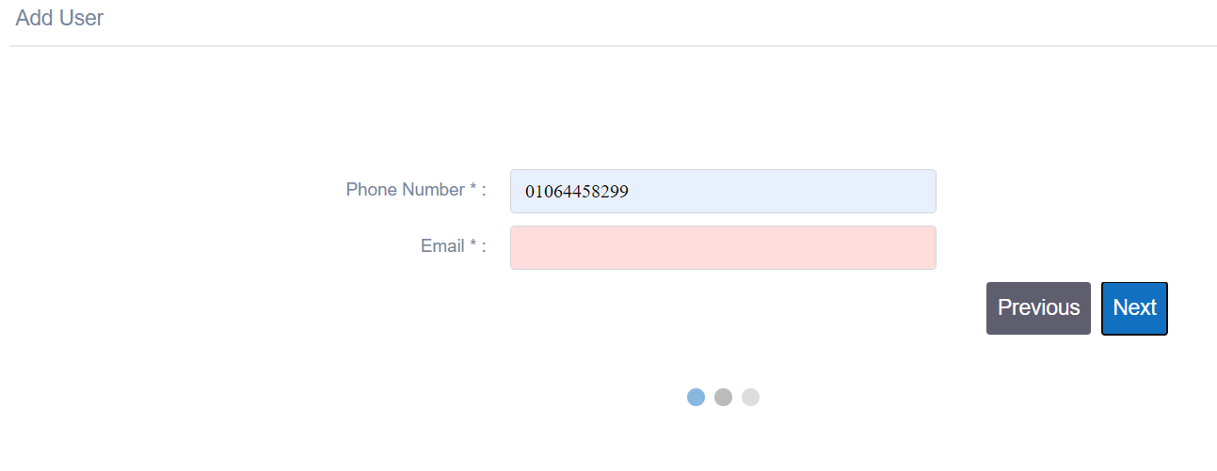

If the admin enters all the field with right format the system will get the last page of step form

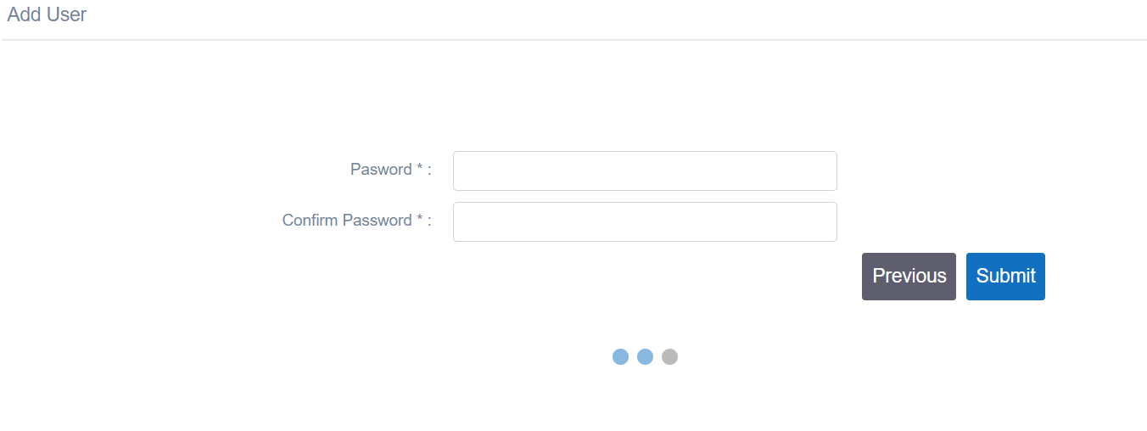

If admin leave any field, the system will give the text area red color

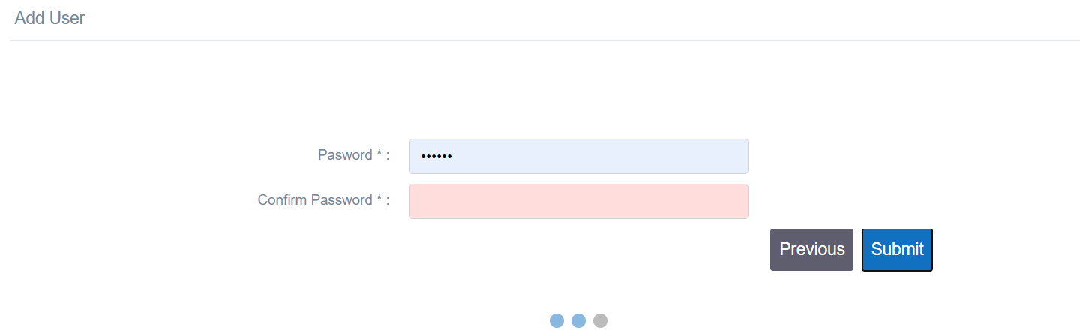

if the admin writes the right data in all steps and press submit the system will message “User created successfully”.

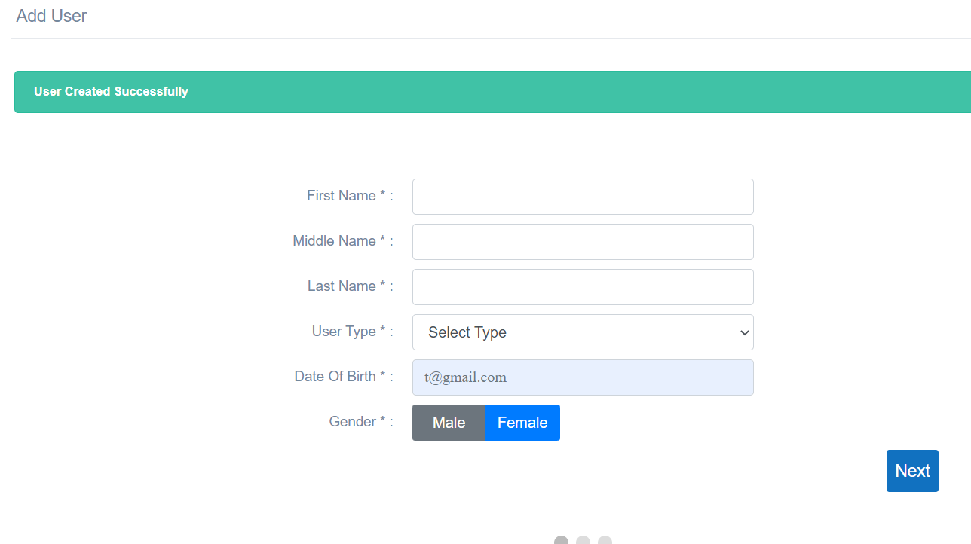

13)Add Operation

To add Operation, the admin have to enter operation type

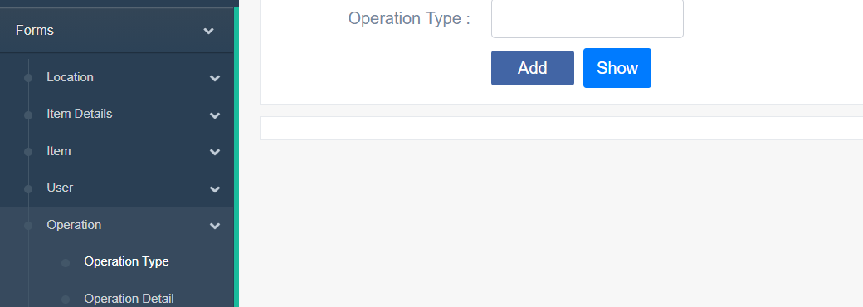

If admin does not enter operation type the system will message “please fill out this field”

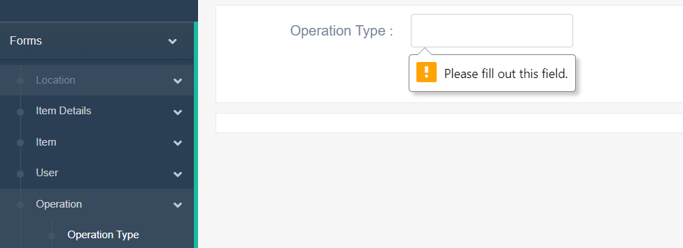

If admin enters operation type with wrong format the system will message “Please match the requested format”

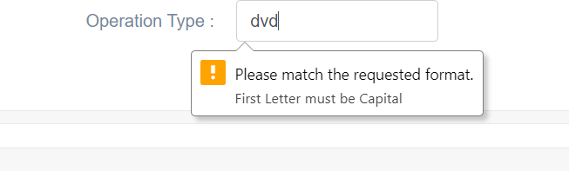

Else the admin enters the right format to operation type the system will message “type created successfully”

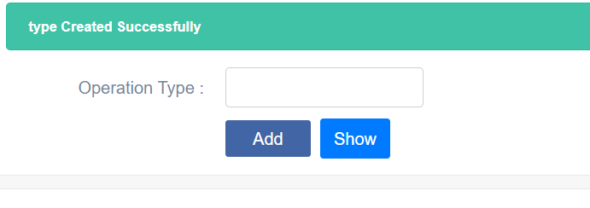

Admin can know all operation type by using show button or choose operation types from table, Operation in slide bar

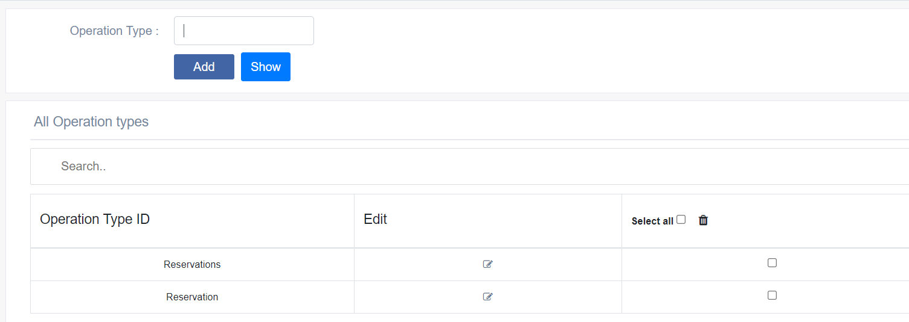

Admin can edit operation type by clicking edit icon

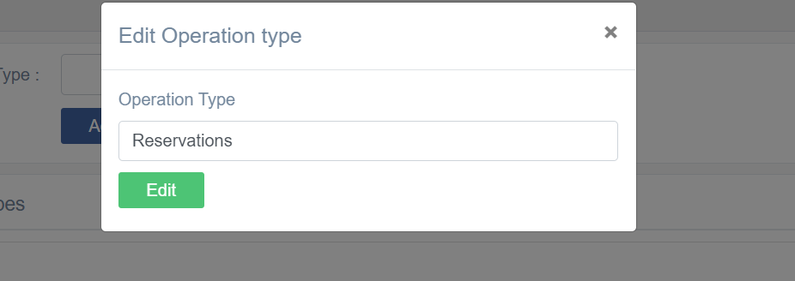

Admin can edit the operation type and clicks edit the system will show message “operation edited successfully”

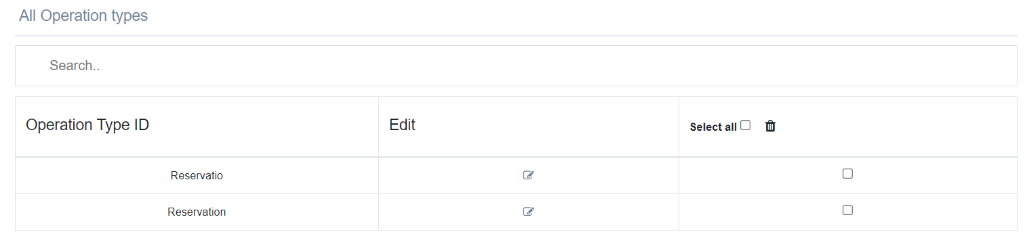

Admin can delete any operation by using the checkbox then clicks trash icon

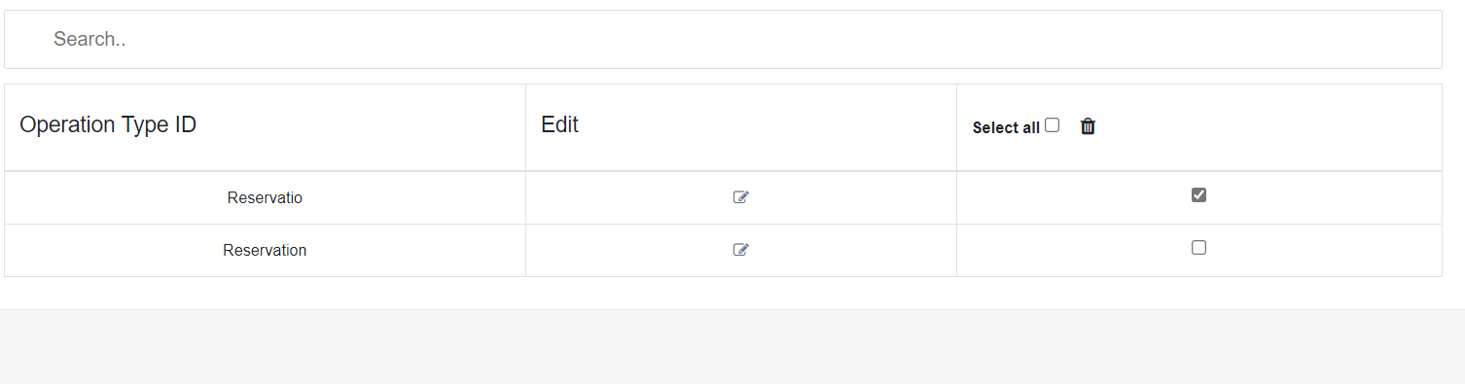

System will show message are you sure you want to delete



If the admin clicks ok the system will redirect same page without the deleting operation and message “Operation name deleted successfully”.

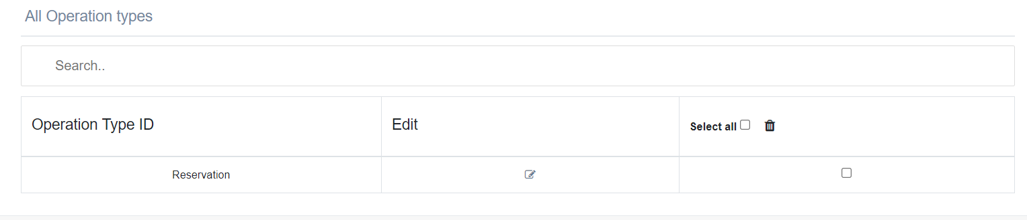

13)Add Operation Detail

Before the admin write operation detail, must choose Operation Name

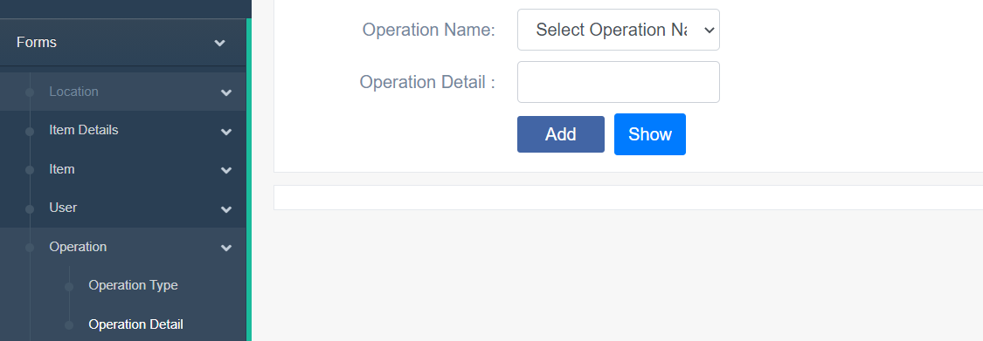

If the admin writes operation name without choosing operation name the system will message “You must select all values”

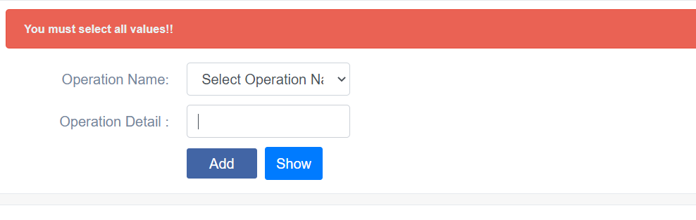

If admin does not enter operation detail the system will message “please fill out this field”



If admin enters operation detail with wrong format the system will message “Please match the requested format”

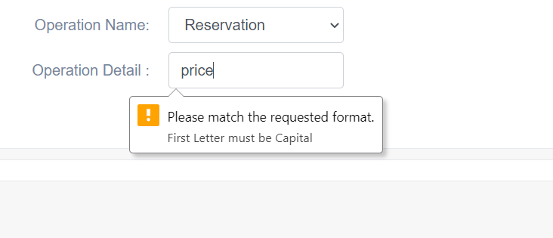

Else the admin enters the right format to operation name the system will message “Detail created successfully”

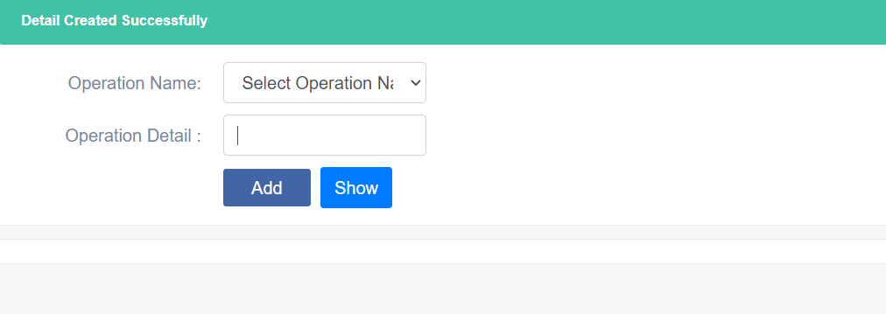

Admin can know all operation names by using show button or choose operation detail from table, operation in slide bar

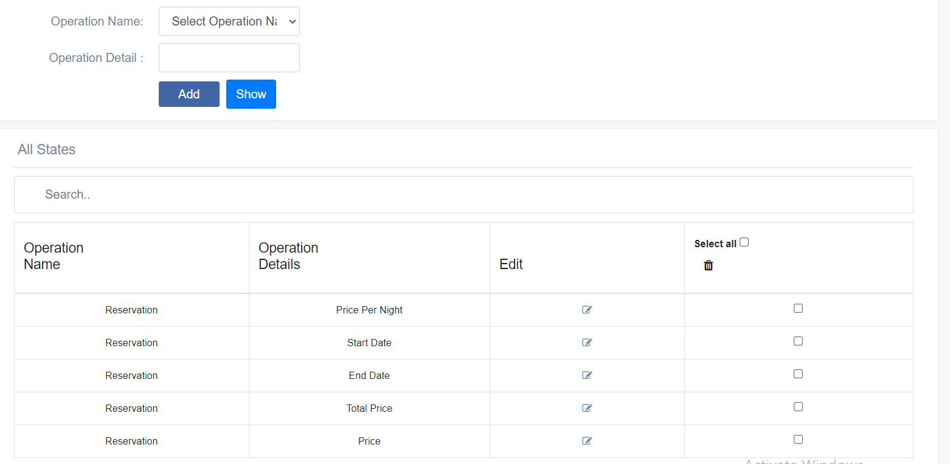

Admin can edit operation type by clicking edit icon

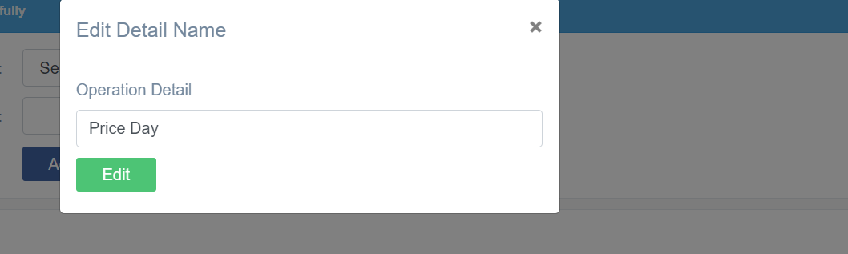

Admin can edit the operation type and clicks edit the system will show message “operation edited successfully”

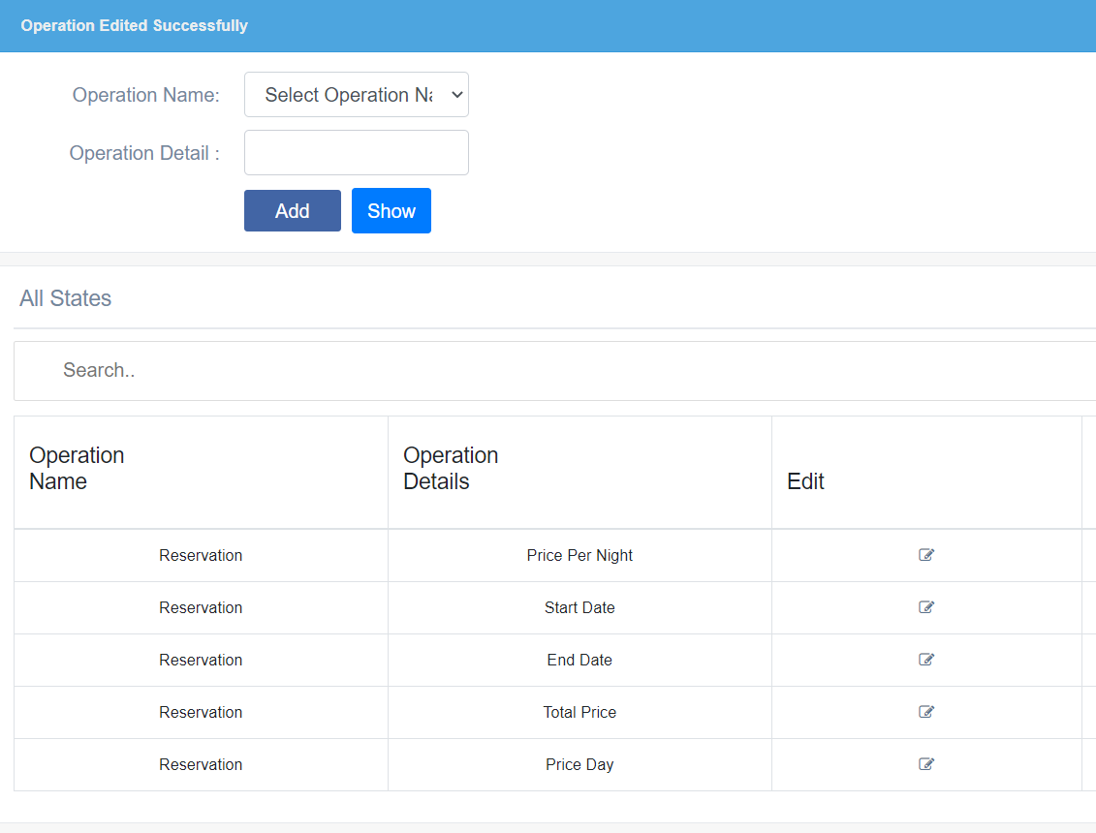

Admin can delete any Operation detail by using the checkbox then clicks trash icon

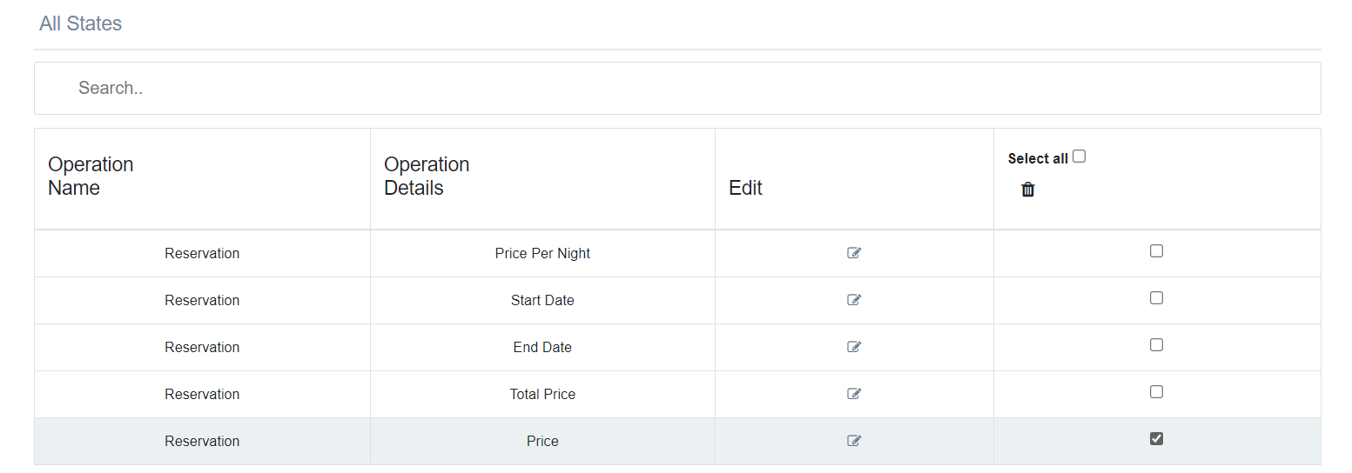

System will show message are you sure you want to delete



If the admin clicks ok the system will redirect same page without the deleting and message “Operation deleted successfully”.

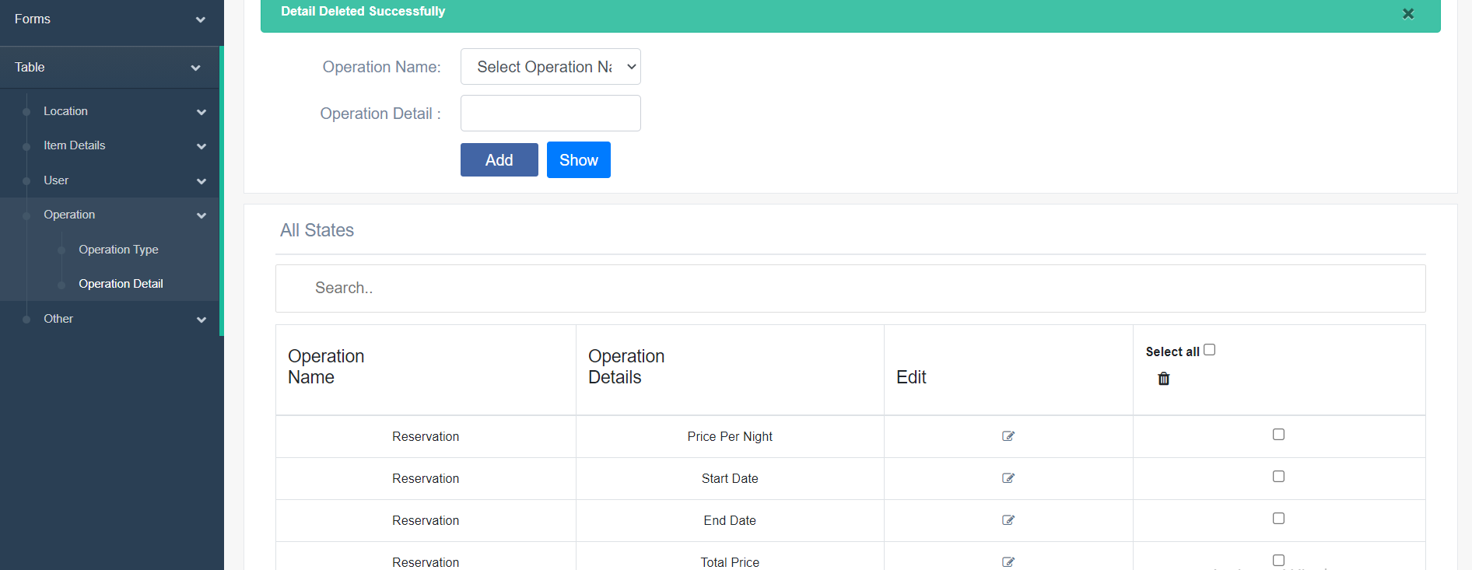

15)Add Data type

To add Data type, the admin has to enter data type

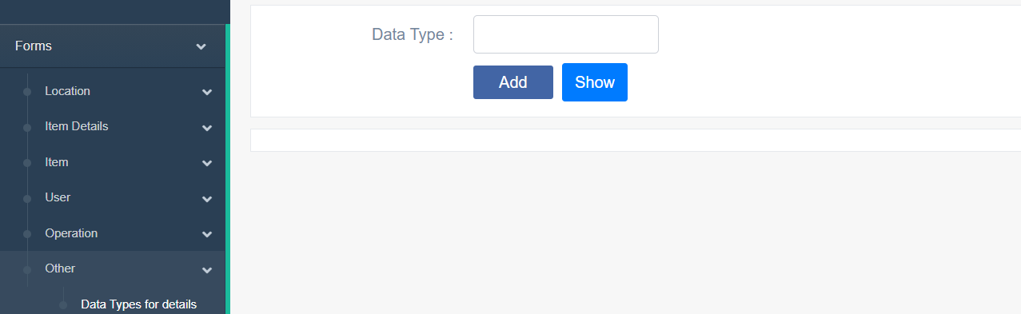

If admin does not enter data type the system will message “please fill out this field”

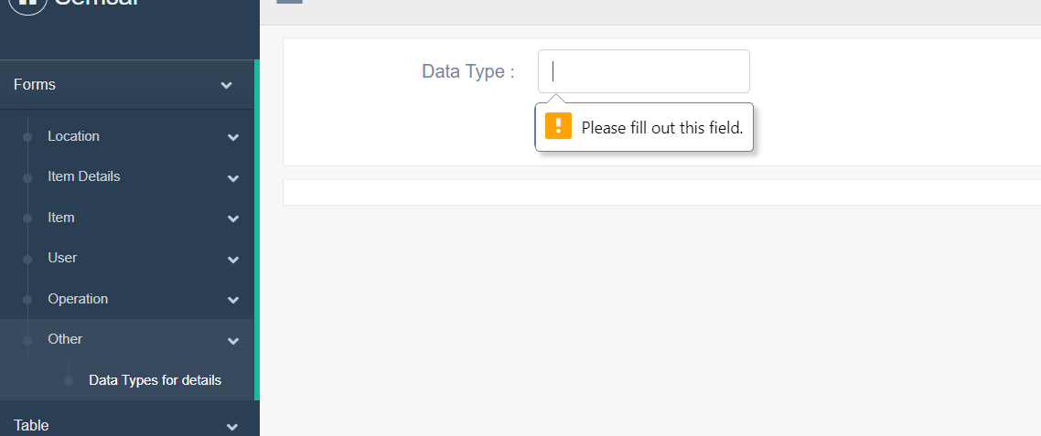

If admin enters data type with wrong format the system will message “Please match the requested format”

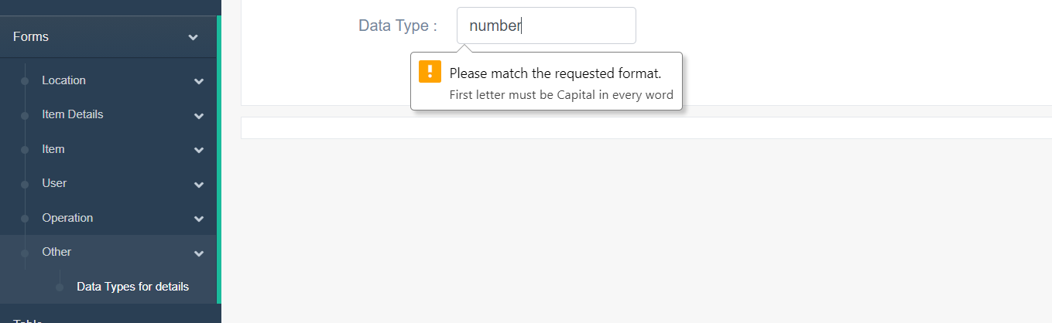

Else the admin enters the right format to data type the system will message “datatype created successfully”

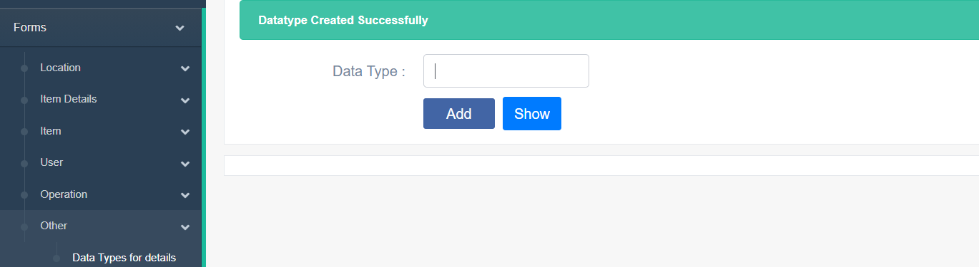

Admin can know all datatypes by using show button or choose data types for details from table, Other in slide bar

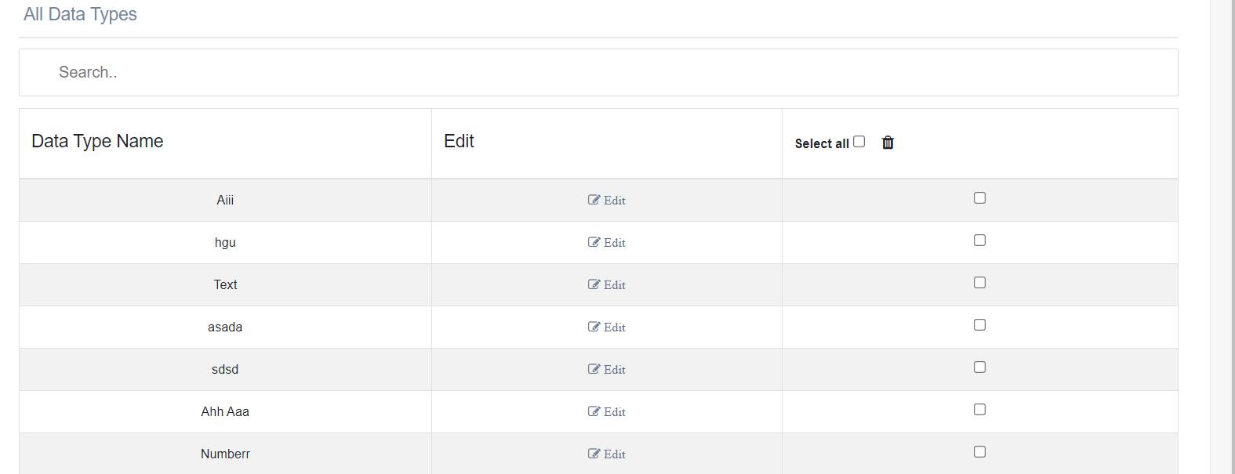

Admin can edit data type by clicking edit icon

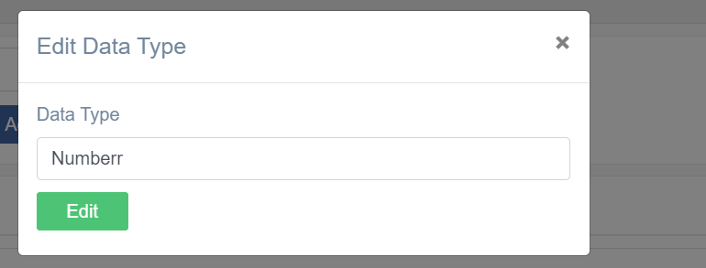

Admin can edit the data type and clicks edit the system will show message “Datatype edited successfully”

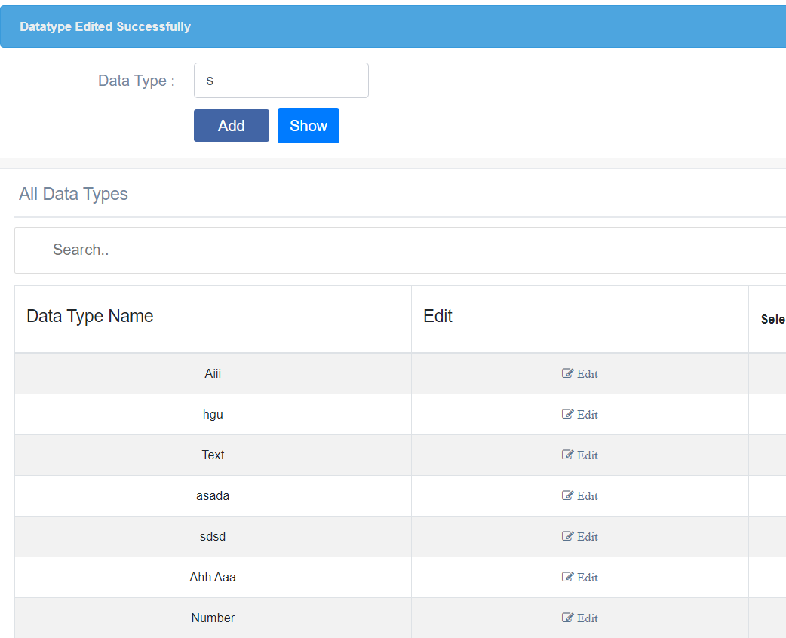

Admin can delete any data type by using the checkbox then clicks trash icon

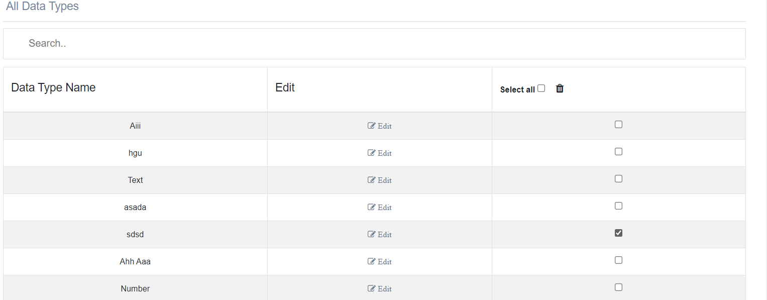

System will show message are you sure you want to delete



If the admin clicks ok the system will redirect same page without the deleting data type and message “Operation name deleted successfully”.

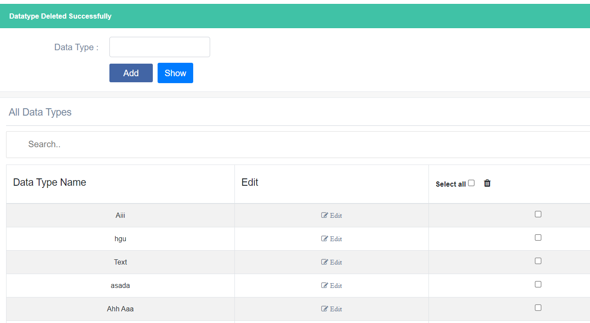

15)Search by state and date

The customer writes state and date

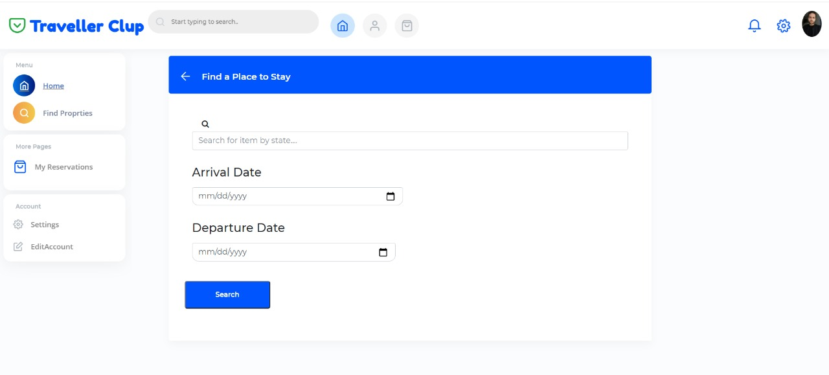

If the customer clicks search and no items available in this date

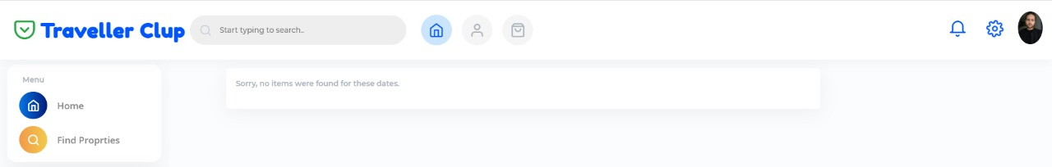

Else the customer will enter available date and state

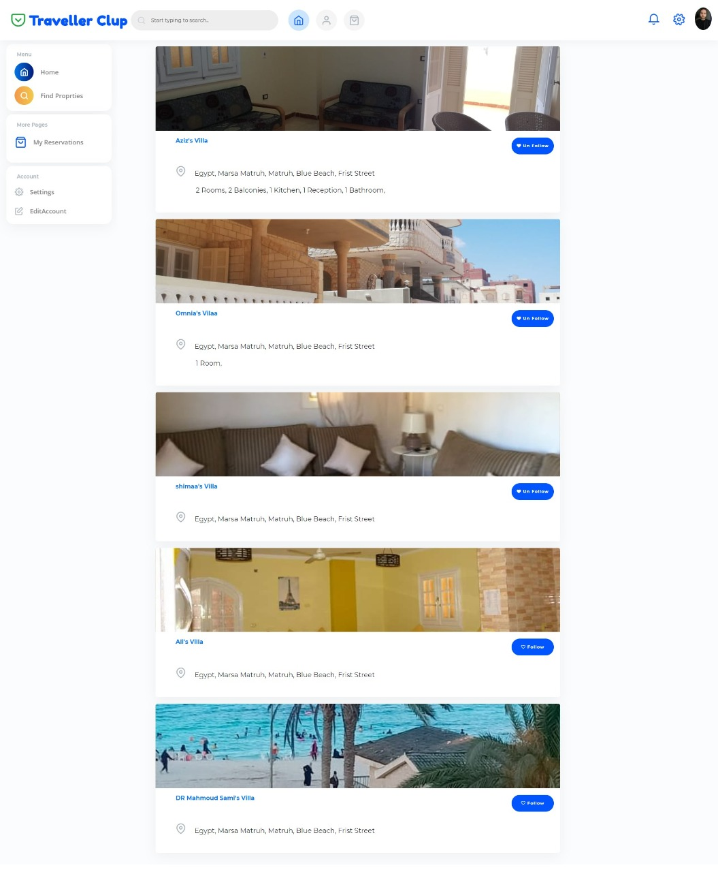

16)Login

The Customer writes email and password to login



If the user enters wrong email or password

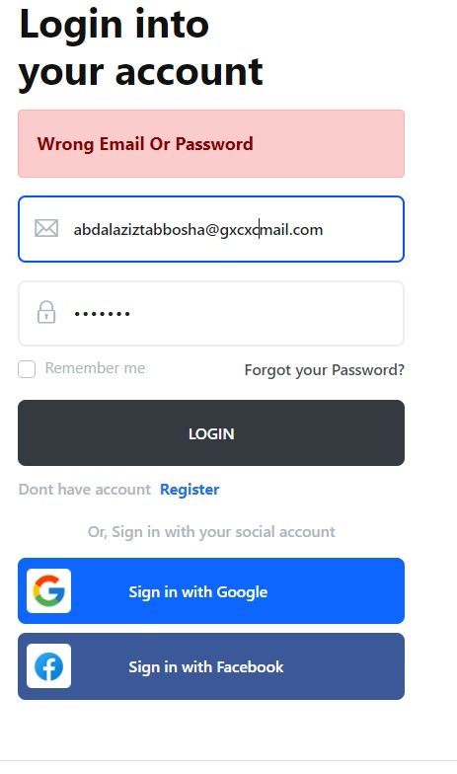

Else the customer enters the right email and password

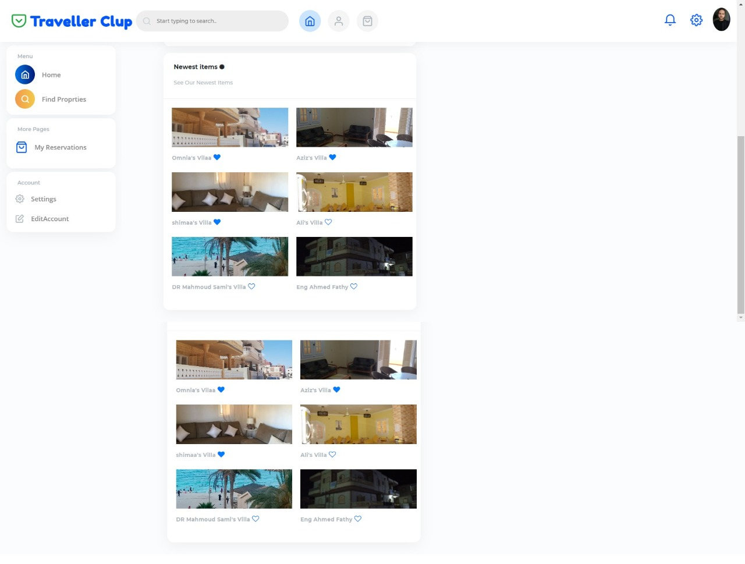

17)Register

The customer enters the email, password and confirm password

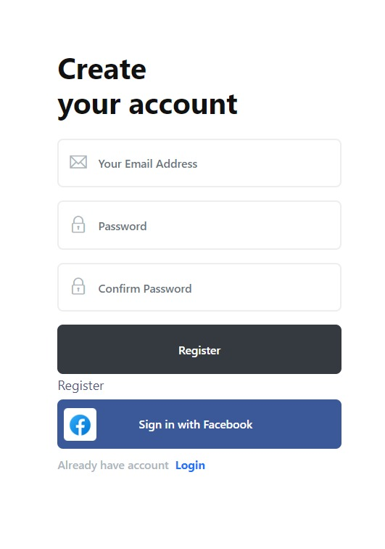

If the customer enters already exist mail

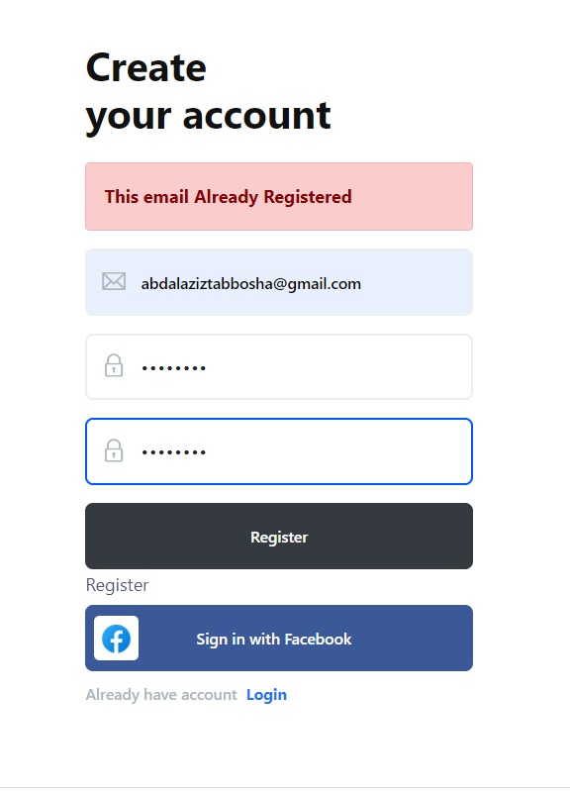

The customer enters a valid email and password not taken before

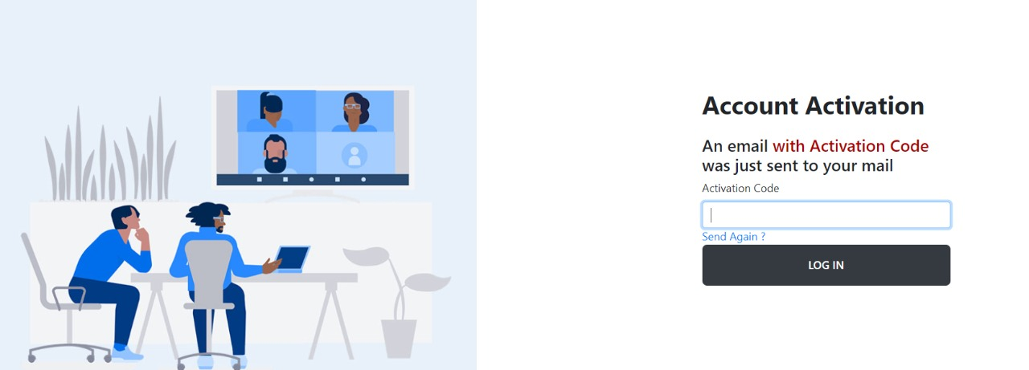

If the customer enters a wrong code

